A PROJECT REPORT ON
AI-POWERED HOUSE PRICE PREDICTION SYSTEM
USING MACHINE LEARNING

Submitted in the partial fulfillment for the award of the degree in

Master of Science
in
DATA SCIENCE
Submitted by

GUNNALA AKSHAY
1107-24-559-003

Under the Guidance of

Mr. MANIKANTA


Department of Data Science under Statistics.
JAHNAVI DEGREE & PG COLLEGE
(Affiliated to OSMANIA UNIVERSITY) Secunderabad, Hyderabad-500003
(2024-2026)

A PROJECT REPORT ON
AI-POWERED HOUSE PRICE PREDICTION SYSTEM
USING MACHINE LEARNING

Submitted in the partial fulfillment for the award of the degree in

Master of Science
in
DATA SCIENCE
Submitted by

GUNNALA AKSHAY
1107-24-559-003

Under the Guidance of

Mr. MANIKANTA


Department of Data Science under Statistics.
JAHNAVI DEGREE & PG COLLEGE
(Affiliated to OSMANIA UNIVERSITY) Secunderabad, Hyderabad-500003
(2024-2026)


JAHNAVI DEGREE & PG COLLEGE
(Affiliated to OSMANIA UNIVERSITY)
1-7-53 & 54/A HMRL P & CA Commercial Complex, Oppo.
Paradise metro station, Beside fire station, S.P. Road, Secunderabad, Hyderabad - 500003

CERTIFICATE

This is to certify that the project entitled on “AI-POWERED HOUSE PRICE PREDICTION SYSTEM USING MACHINE LEARNING” is a bonafide work done by G.AKSHAY, bearing Roll no (110724559003) the mentioned person has carried out project work at the department of Data Science, JAHNAVI DEGREE & PG COLLEGE during fourth Semester.

Head of the Department Principal

Project Guide External Examiner

ACKNOWLEDGEMENT

It is a matter of immense pleasure and privilege to pay special thanks to Mr. MANIKANTA, Lecturer, JAHNAVI DEGREE & PG COLLEGE, who patiently supervised this work with a great critical insight and intellectual acumen. Under him guidance, things always looked within reach. In fact, without him/her consistent critical suggestions, cheerful encouragement and sincere cooperation, this report should have remained futile. I express my cordial thanks to other members of teaching faculty of this department for their valuable help and cooperation.
I would like to express my gratitude for all the people who extended unending support at all stages of the project.
My special thanks to Mr. MANIKANTA, Head of Department, for her support and cooperation during the course of the project.
I wish to express my sincere thanks to Dr. M. NARSING RAO, Principal, JAHNAVI DEGREE & PG COLLEGE for the valuable inputs and guidance provided through my project.
I hereby express our sincere thanks to all teaching staff, parents and friends who is extended their help hand in the accomplishment of the project.

G.AKSHAY 110724559003

STUDENT DECLARATION

We hereby declare that the project report entitled “AI-POWERED HOUSE PRICE PREDICTION SYSTEM USING MACHINE LEARNING” submitted in partial fulfilment of the requirement for the award of Master of Science Degree from JAHNAVI DEGREE & PG COLLEGE, Affiliated to Osmania University under the guidance of Mr. MANIKANTA, is an original piece of work. The results drawn are based on structured primary data used for analytical and research purposes. Primary data wherever used has been duly acknowledged and cited appropriately in the report. No part of this report has been submitted for evaluation elsewhere for the award for any degree.

G.AKSHAY 110724559003

SUPERVISOR CERTIFICATE

I certify that the project report entitled “AI- POWRED HOUSE PRICE PREDICTION SYSTEM USING MACHINE LEARNING” submitted for the Master of Science degree by, G.AKSHAY(110724559003)is an original research work carried out by him during the period from 2024 to 2026 under my guidance and supervision. Further, this work has not been submitted elsewhere for the award of any Degree, Diploma, or other Titles in this university or any other university or institute of higher learning.

Mr. MANIKANTA

INDEX
S.NO | TOPICS 3 | PAGE NO
 | ABSTRACT | 1
1 | INTRODUCTION | 2 – 9
1.1 | INTRODUCTION | 2-3
1.2 | REAL ESTATE MARKET ANALYSIS &SIGNIFICANCE OF HOUSE PRICE PREDICTION | 3-4
1.3 | ROLE OF HOUSE PRICE PREDICTION | 4-5
1.4 | NEED OF THE HOUSE PRICE PREDICTION | 5-6
1.5 | STATEMENT OF THE PROBLEM | 6
1.6 | OBJECTIVES | 6-7
1.7 | SYSTEM OVERVIEW | 7 -8
1.8 | SYSTEM FEATURES | 8 -9
2 | REVIEW OF LITERATURE | 10-12
2.1 | LITERATURE REVIEW | 10-11
2.2 | RELEVANT WORKS | 12
3 | METHODOLOGY | 13-34
3.1 | THEORY | 13-15
3.2 | MATERIALS | 15-17
3.3 | DATASET | 17-23

3.4 | PROPOSED SYSTEM | 24-26
3.5 | SYSTEM ARCHITECTURE | 26-28
3.6 | DATA PREPROCESSING | 29-32
3.7 | MODEL SELECTION AND JUSTIFICATION | 32-34
4 | DATA ANALYSIS AND RESULTS | 35
4.1 | IMPORTING LIBRARIES AND LOADING DATASET | 35
4.2 | UNDERSTANDING THE DATA | 35
4.2.1 | Dataset Dimensions | 35-36
4.2.2 | Initial Data Inspection | 36-37
4.2.3 | Attributes Missing Value Analysis | 38-39
4.2.4 | Duplicate Record Analysis | 39
4.2.5 | Dataset Structure and Data Types | 39-41
4.2.6 | Removal of Irrelevant features | 41
4.2.7 | Statistical Summary of Numerical Features | 41-42
4.2.8 | Statistical Hypothesis | 43-46
4.2.9 | House Price Distribution | 47
4.2.10 | City Wise Price Analysis | 48-49
4.2.11 | Number of Bedrooms VS House Price | 49-51
4.2.12 | Average House Price by City | 51-52
4.2.13 | Correlation Heatmap analysis | 52-54
4.2.14 | Top locations | 54-55
4.3 | MODEL DEVELOPMENT | 55
4.3.1 | Encoding Categorical Variables | 55
4.3.2 | Feature Selection and Target Variable | 56
4.3.3 | Train–Test Split | 56-58
4.3.4 | Importing machine learning Libraries | 58
4.3.5 | Linear Regression – Model Evaluation | 59-60
4.3.6 | Decision Tree - Model Evaluation | 61-62
4.3.7 | Random Forest– Model Evaluation | 63-65
4.3.8 | Gradient Boosting-Model Evaluation | 65-67
4.3.9 | XGBoost-Model Evaluation | 67-69
4.3.10 | Comparision of ml models | 70-72
4.3.11 | Hyper parameter Tuning | 72-28
4.3.12 | New House Prediction | 79-80
4.4 | RESULTS AND DISCUSSION | 81-83
4.4.1 | Discussion of Model Performance | 81-83
5 | CONCLUSION | 84-89
5.1 | CONCLUSION | 84-85
5.2 | LIMITATIONS | 86-87
5.3 | FUTURE SCOPE | 88-89
6. | REFERENCES | 90
7. | WEBSITES | 91

ABSTRACT
The real estate industry generates large volumes of property data, making accurate house price prediction an important task for buyers, sellers, investors, financial institutions, and real estate developers. Property prices are influenced by several factors, including city, locality, property type, built-up area, carpet area, number of bedrooms, bathrooms, parking facilities, furnishing status, property age, security score, accessibility to metro stations, nearby schools, hospitals, and distance from the city center. Traditional property valuation methods often rely on manual assessment and expert judgment, which may be subjective and time-consuming. Therefore, developing an intelligent, data-driven house price prediction system using statistical analysis and machine learning techniques has become increasingly important.
This project proposes an AI-Powered House Price Prediction and Real Estate Analytics System using a housing dataset containing 50,000 residential property records with 30 variables collected from major Indian metropolitan cities.
The dataset is preprocessed through data cleaning, missing value analysis, categorical encoding, and exploratory data analysis (EDA). Descriptive statistical techniques such as mean, median, standard deviation, variance, skewness, and kurtosis are used to summarize the data, while visualizations including histograms, box plots, scatter plots, and correlation heatmaps provide insights into the relationships among variables. Statistical techniques such as Pearson Correlation Analysis, Multiple Linear Regression, One-Way ANOVA, Chi-Square Test, and Principal Component Analysis (PCA) are applied to identify significant factors affecting house prices.
Several machine learning algorithms, including Linear Regression, Ridge Regression, Decision Tree Regression, Random Forest Regression, Gradient Boosting Regression, XGBoost, are developed and compared using evaluation metrics such as MAE, MSE, RMSE, and R² Score. An Artificial Neural Network (ANN) is also implemented to evaluate deep learning performance. Furthermore, Explainable Artificial Intelligence (XAI) using SHAP is employed to interpret model predictions and identify the most influential features affecting house prices.
The proposed system provides accurate and reliable house price predictions while offering valuable insights into the key factors influencing property values. It serves as an intelligent decision-support tool for buyers, sellers, investors, and real estate professionals and demonstrates the effective integration of statistical analysis, machine learning, deep learning, and explainable AI for real-world real estate analytics.

1. INTRODUCTION

1.1 INTRODUCTION
The real estate industry is one of the fastest-growing sectors and plays an important role in the country's economic development. Accurate house price prediction is essential for home buyers, sellers, investors, banks, and real estate agencies to make informed decisions. House prices are influenced by several factors such as city, locality, property type, built-up area, carpet area, number of bedrooms and bathrooms, property age, parking facilities, and nearby amenities.
Traditional methods of estimating house prices are often based on manual evaluation and market experience, which can be time-consuming and may not always provide accurate results. With the availability of large real estate datasets and advancements in machine learning, it is now possible to predict house prices more accurately using data-driven techniques.
This project develops an AI-Powered House Price Prediction and Real Estate Analytics System using a housing dataset containing 50,000 property records with 30 features collected from major Indian metropolitan cities. The project includes data preprocessing, exploratory data analysis (EDA), descriptive statistics, statistical hypothesis testing, and visualization to understand the factors affecting house prices.
Multiple machine learning models, including Linear Regression, Ridge Regression, Decision Tree, Random Forest, Gradient Boosting, XGBoost, are implemented and compared using performance metrics such as MAE, MSE, RMSE, and R² Score. An Artificial Neural Network (ANN) and SHAP (SHapley Additive exPlanations) are also used to improve prediction performance and explain the model's decisions.
The main objective of this project is to develop an accurate, reliable, and interpretable house price prediction system that supports data-driven decision-making in the real estate sector.
1.2 REAL ESTATE MARKET ANALYSIS
Real Estate Market Analysis is an important component of the proposed AI-Powered House Price Prediction System. It involves analyzing historical housing data to identify pricing patterns, market trends, and the key factors that influence property values. By examining multiple property attributes such as location, built-up area, carpet area, number of bedrooms, bathrooms, furnishing status, amenities, and proximity to essential facilities, the system provides valuable insights into the real estate market.
In this project, a large-scale housing dataset containing approximately 50,000 property records from major metropolitan cities such as Bangalore, Hyderabad, Mumbai, and Delhi was analyzed. Exploratory Data Analysis (EDA) was performed to understand the distribution of house prices, detect outliers, identify correlations among variables, and evaluate the impact of different property features on housing prices.
The analysis revealed that several factors significantly influence house prices. Properties with larger built-up areas, higher carpet areas, additional bedrooms and bathrooms, premium locations, and better amenities generally have higher market values. Correlation analysis further confirmed strong relationships between these features and the target variable, price_in_lakhs.
To improve prediction performance, data preprocessing techniques including duplicate removal, missing value verification, feature encoding using One-Hot Encoding, and train-test splitting were applied. Five machine learning regression models—Linear Regression, Decision Tree Regressor, Random Forest Regressor, Gradient Boosting Regressor, and XGBoost Regressor—were trained and evaluated using Mean Absolute Error (MAE), Mean Squared Error (MSE), Root Mean Squared Error (RMSE), and R² Score.
Among all models, XGBoost achieved the highest prediction accuracy in terms of R² Score while producing the lowest MAE, MSE, and RMSE values. Therefore, XGBoost was selected as the final predictive model for the proposed system.
To increase transparency and interpretability, SHAP (SHapley Additive Explanations) was integrated with the XGBoost model. SHAP explains how individual features contribute to each predicted house price by assigning contribution values to every input feature. This enables users to understand the reasons behind the predicted property price rather than receiving only a numerical prediction.
The proposed AI-Powered House Price Prediction System not only estimates property prices with high accuracy but also performs comprehensive real estate market analysis by identifying significant pricing factors, comparing machine learning models, interpreting predictions through Explainable AI, and providing meaningful insights for buyers, sellers, investors, and real estate professionals. This intelligent decision-support system assists stakeholders in making informed property investment and pricing decisions based on data-driven analysis.
SIGNIFICANCE OF THE STUDY
The real estate industry generates a large amount of property-related data, making accurate house price prediction a challenging task. Traditional property valuation methods mainly rely on manual estimation, expert opinions, and historical comparisons, which may be time-consuming, subjective, and less accurate. Therefore, there is a need for an intelligent and data-driven system that can accurately predict house prices and provide meaningful insights into the real estate market.
The significance of this study lies in the development of an AI-Powered House Price Prediction and Real Estate Market Intelligence System using advanced machine learning techniques. The proposed system analyzes various property attributes such as location, built-up area, carpet area, number of bedrooms, bathrooms, furnishing status, amenities, and accessibility to estimate property prices with high accuracy.
This study compares the performance of five machine learning algorithms: Linear Regression, Decision Tree Regressor, Random Forest Regressor, Gradient Boosting Regressor, and XGBoost Regressor. Based on comprehensive evaluation using MAE, MSE, RMSE, and R² Score, the XGBoost model was identified as the most effective prediction model due to its superior predictive performance.
A significant contribution of this research is the integration of Explainable Artificial Intelligence (XAI) through SHAP (SHapley Additive Explanations). SHAP provides transparent explanations by identifying the contribution of each feature toward the predicted house price. This improves the interpretability and trustworthiness of the AI model, enabling users to understand why a particular property is valued at a specific price.
The proposed system benefits multiple stakeholders in the real estate sector. Home buyers can estimate fair market prices before purchasing properties, sellers can determine competitive listing prices, real estate agents can make data-driven recommendations to clients, investors can identify profitable investment opportunities, and financial institutions can perform more reliable property valuation for loan approval and risk assessment.
Furthermore, the system supports informed decision-making by analyzing market trends, identifying the most influential pricing factors, and generating accurate predictions from historical housing data. The research also demonstrates the practical application of machine learning and Explainable AI in solving real-world problems within the real estate domain.
Overall, this study contributes to the development of an intelligent, reliable, and transparent property valuation system that enhances decision-making, improves pricing accuracy, and promotes the adoption of Artificial Intelligence in the real estate industry.

1.3 ROLE OF HOUSE PRICE PREDICTION
House price prediction plays an important role in the real estate industry by providing accurate and data-driven estimates of property values. It helps buyers determine whether a property is fairly priced and enables sellers to set competitive prices based on market conditions. Financial institutions use house price prediction to evaluate property values before approving home loans, while investors use it to identify profitable investment opportunities.
With the growth of machine learning and data analytics, house price prediction has become more reliable by analyzing multiple factors such as location, property size, number of bedrooms and bathrooms, property age, nearby amenities, and accessibility. These techniques reduce manual effort, improve prediction accuracy, and support informed decision-making.
In this project, statistical analysis, machine learning, and explainable artificial intelligence (SHAP) are used to predict house prices and identify the key factors influencing property values. The developed system provides a reliable decision-support tool for buyers, sellers, investors, banks, and real estate professionals, contributing to a more transparent and efficient real estate market.

1.4 NEED OF THE PROJECT

The real estate sector is one of the fastest-growing industries, where property prices continuously change due to factors such as location, property size, market demand, infrastructure development, economic conditions, and available amenities. Estimating the correct market value of a property using traditional methods is often difficult because it depends heavily on manual analysis, historical comparisons, and expert judgment. These approaches may lead to inaccurate pricing, increased processing time, and inconsistent valuation results.
The need for this project arises from the growing demand for an intelligent and automated system that can accurately estimate house prices using historical real estate data. With the rapid growth of Artificial Intelligence (AI) and Machine Learning (ML), it has become possible to analyze large volumes of housing data, identify hidden patterns, and generate highly accurate property price predictions.
The proposed AI-Powered House Price Prediction and Real Estate Market Intelligence System addresses these challenges by utilizing machine learning algorithms to predict house prices based on multiple property features such as location, built-up area, carpet area, number of bedrooms, bathrooms, furnishing status, parking availability, and nearby facilities. The system automates the price estimation process, reducing human effort while improving prediction accuracy and consistency.
To identify the most suitable prediction technique, five machine learning models—Linear Regression, Decision Tree Regressor, Random Forest Regressor, Gradient Boosting Regressor, and XGBoost Regressor—were developed and compared. Their performance was evaluated using MAE, MSE, RMSE, and R² Score. Among these models, XGBoost produced the best results and was selected as the final prediction model.
In addition to accurate prediction, the project incorporates Explainable Artificial Intelligence (XAI) using SHAP (SHapley Additive Explanations). SHAP explains how each input feature contributes to the predicted house price, making the model transparent, trustworthy, and easier to interpret. This helps users understand the reasons behind each prediction rather than relying only on the final output.
The proposed system serves as an intelligent decision-support tool for home buyers, sellers, real estate agents, investors, financial institutions, and property developers. It enables users to estimate fair property values, analyze market trends, compare pricing factors, and make informed investment decisions based on data-driven insights.
Therefore, this project fulfills the need for a reliable, accurate, explainable, and AI-based house price prediction system that supports efficient property valuation and enhances decision-making in the real estate market.

1.5 STATEMENT OF THE PROBLEM
Accurate prediction of house prices is a challenging task due to the influence of multiple factors such as location, property type, built-up area, number of bedrooms and bathrooms, property age, parking facilities, and nearby amenities. Traditional property valuation methods mainly depend on manual assessment, market experience, and expert judgment, which may result in inconsistent and inaccurate price estimates.
With the availability of large-scale housing data, there is a need for an intelligent system that can analyze various property characteristics and predict house prices more accurately. This project addresses this problem by applying statistical analysis, machine learning, and deep learning techniques to develop a reliable house price prediction model. The system also identifies the key factors influencing property prices, enabling buyers, sellers, investors, and real estate professionals to make informed and data-driven decisions.

OBJECTIVES

• To develop an AI-based house price prediction system using machine learning techniques for accurate estimation of residential property prices.

• To collect and analyze a large-scale housing dataset containing residential property information from major Indian metropolitan cities.

• To perform data preprocessing by handling missing values, duplicate records, feature encoding, and preparing the dataset for statistical analysis and machine learning.

• To conduct Exploratory Data Analysis (EDA) using various visualization techniques such as histograms, box plots, scatter plots, bar charts, and correlation heatmaps to understand the characteristics of the housing dataset.
• To apply descriptive statistical techniques including mean, median, mode, variance, standard deviation, range, quartiles, skewness, and kurtosis for summarizing the dataset.

• To perform statistical hypothesis testing using Pearson Correlation Analysis, Multiple Linear Regression, One-Way ANOVA, Chi-Square Test, and Principal Component Analysis (PCA) to identify significant factors influencing house prices.

• To develop and compare multiple machine learning regression models, including Linear Regression, Decision Tree Regressor, Random Forest Regressor, Gradient Boosting Regressor, and XGBoost Regressor, for house price prediction.

• To evaluate the performance of machine learning models using regression metrics such as Mean Absolute Error (MAE), Mean Squared Error (MSE), Root Mean Squared Error (RMSE), and R² Score.

• To optimize the best-performing machine learning model through hyperparameter tuning in order to improve prediction accuracy and model robustness.

• To implement Explainable Artificial Intelligence (XAI) using SHAP (SHapley Additive exPlanations) to interpret the contribution of individual features toward house price prediction.

• To identify the most influential property characteristics affecting residential house prices through feature importance analysis and SHAP visualizations.

• To develop a reliable decision-support system that assists home buyers, sellers, investors, banks, and real estate professionals in making accurate and data-driven property valuation decisions.

1.7 SYSTEM OVERVIEW

The proposed system is an AI-Powered House Price Prediction and Real Estate Analytics System developed to estimate residential property prices using statistical analysis, machine learning, and deep learning techniques. The system utilizes a housing dataset containing 50,000 property records with 30 features, including city, locality, property type, built-up area, carpet area, number of bedrooms and bathrooms, property age, parking facilities, security score, and nearby amenities.
The system begins by collecting and preprocessing the housing dataset through data cleaning, handling missing values, duplicate removal, and categorical data encoding. Exploratory Data Analysis (EDA) and descriptive statistical analysis are then performed to understand the characteristics of the data and identify relationships among different variables.
Statistical techniques such as Pearson Correlation Analysis, One-Way ANOVA, Chi-Square Test, and Principal Component Analysis (PCA) are applied to analyze significant factors affecting house prices. Multiple machine learning models, including Linear Regression, Decision Tree, Random Forest, Gradient Boosting, XGBoost, are trained and evaluated using performance metrics such as MAE, MSE, RMSE, and R² Score.
To improve transparency, the system incorporates SHAP (SHapley Additive exPlanations), which explains the contribution of each feature to the predicted house price. The final system provides accurate house price predictions along with feature importance analysis, enabling buyers, sellers, investors, banks, and real estate professionals to make informed and data-driven decisions.

1.8 SYSTEM FEATURES

The proposed House Price Prediction System incorporates several features that improve the accuracy of property price estimation and provide meaningful insights into housing data. The major features of the system are

House Price Prediction

The system performs supervised regression to estimate residential property prices based on various property and location attributes. Machine learning algorithms including Linear Regression, Decision Tree Regressor, Random Forest Regressor, Gradient Boosting Regressor, and XGBoost Regressor are trained using historical housing data to accurately predict house prices.

Property and Market Analysis
The system provides comprehensive exploratory analysis of housing characteristics such as built-up area, carpet area, number of bedrooms, bathrooms, balconies, parking spaces, furnishing status, property age, locality tier, and accessibility to nearby facilities. Visualization techniques including histograms, box plots, scatter plots, violin plots, pair plots, and correlation heatmaps are used to identify trends, distributions, and relationships among property attributes.

Statistical Analysis and Hypothesis Testing
The system applies descriptive statistics and statistical hypothesis testing to understand the housing dataset and identify significant factors affecting property prices. Techniques such as Pearson Correlation Analysis, Multiple Linear Regression, One-Way ANOVA, Chi-Square Test, and Principal Component Analysis (PCA) are used to evaluate relationships between variables and validate statistical assumptions.

Model Evaluation and Performance Comparison
The system evaluates the prediction performance of multiple regression models using standard evaluation metrics including Mean Absolute Error (MAE), Mean Squared Error (MSE), Root Mean Squared Error (RMSE), and R² Score. Comparative analysis is performed to identify the most accurate model for house price prediction.
Feature Importance and Explainable AI
The system identifies and ranks the most influential property attributes affecting house prices using feature importance analysis and SHAP (SHapley Additive exPlanations). This provides interpretable insights into how variables such as property area, locality, property type, number of bedrooms, and nearby amenities contribute to the predicted house price, improving the transparency and reliability of the prediction model..

2. REVIEW OF LITERATURE

2.1 LITERATURE REVIEW

The real estate industry has become one of the most significant contributors to economic growth and urban development. With increasing urbanization, rising population, and growing demand for residential properties, determining the market value of a house has become a complex task. House prices depend on several factors, including location, built-up area, carpet area, property type, number of bedrooms and bathrooms, property age, parking availability, accessibility to public facilities, and neighborhood characteristics. Since these factors have both linear and nonlinear relationships with property prices, traditional valuation methods often fail to produce accurate estimates. Consequently, researchers have increasingly adopted statistical analysis and machine learning techniques to improve the accuracy and reliability of house price prediction.
Early research in house price prediction primarily focused on statistical regression techniques, particularly Multiple Linear Regression. These models established relationships between the selling price of a property and its physical and geographical characteristics. Variables such as built-up area, location, number of bedrooms, and property age were identified as significant determinants of house prices. Although regression models are easy to implement and interpret, they assume a linear relationship among variables and often perform poorly when dealing with complex housing datasets containing nonlinear patterns and interactions between features.
As the availability of housing data increased, machine learning techniques became widely adopted for property price prediction. Decision Tree Regression introduced a rule-based approach capable of handling nonlinear relationships and interactions among multiple variables. Random Forest Regression further improved prediction performance by combining multiple decision trees, reducing overfitting, and improving model stability. Ensemble learning methods such as Gradient Boosting Regression and XGBoost demonstrated higher prediction accuracy by sequentially learning from previous errors and optimizing prediction performance. These models have become popular because of their ability to process large datasets, handle complex feature interactions, and provide robust predictions.
Exploratory Data Analysis (EDA) has become an essential stage in modern predictive analytics. Researchers have shown that understanding data distributions, identifying missing values, detecting outliers, and analyzing feature relationships significantly improve model performance. Visualization techniques such as histograms, box plots, density plots, scatter plots, violin plots, pair plots, and correlation heatmaps are commonly used to understand the characteristics of housing datasets before model development. These visualizations help identify trends, feature distributions, unusual observations, and relationships among variables, leading to better feature selection and improved prediction accuracy.
Statistical analysis also plays a crucial role in housing price prediction. Descriptive statistical measures including mean, median, mode, variance, standard deviation, quartiles, skewness, and kurtosis provide a comprehensive summary of housing data. Statistical hypothesis testing methods such as Pearson Correlation Analysis, One-Way ANOVA, Chi-Square Test, and Principal Component Analysis (PCA) are widely used to determine significant relationships between property attributes and house prices. These methods assist researchers in validating assumptions, identifying influential variables, reducing feature dimensionality, and improving the interpretability of predictive models.
Recent developments in Explainable Artificial Intelligence (XAI) have further improved the usability of machine learning models. Although ensemble learning algorithms achieve high prediction accuracy, they are often considered black-box models because their decision-making process is difficult to interpret. SHAP (SHapley Additive exPlanations) has emerged as one of the most effective explainability techniques for interpreting machine learning predictions. SHAP quantifies the contribution of each feature toward the predicted house price, allowing users to understand how variables such as locality, built-up area, property type, property age, and nearby amenities influence the final prediction. This improves user confidence and supports transparent decision-making in real estate applications.
Despite significant advancements, many existing studies focus mainly on prediction accuracy while providing limited statistical interpretation and feature-level analysis. Some studies also use relatively small datasets or implement only one or two machine learning models, limiting the reliability of their findings. Furthermore, several prediction systems do not integrate comprehensive exploratory data analysis, statistical hypothesis testing, and explainable artificial intelligence within a single framework.
The present study addresses these limitations by developing an AI-based House Price Prediction and Real Estate Analytics System using a housing dataset containing 50,000 residential property records with 30 variables. The proposed framework integrates descriptive statistics, exploratory data analysis, statistical hypothesis testing, machine learning algorithms including Linear Regression, Decision Tree Regression, Random Forest Regression, Gradient Boosting Regression, and XGBoost Regression, along with SHAP-based Explainable Artificial Intelligence. Model performance is evaluated using MAE, MSE, RMSE, and R² Score to identify the most accurate prediction model. The developed system not only predicts house prices with high accuracy but also provides meaningful insights into the factors influencing residential property values, making it a valuable decision-support tool for buyers, sellers, investors, banks, and real estate professionals.

2.2 RELEVANT WORKS

Several studies have been conducted to improve the accuracy of house price prediction using statistical analysis and machine learning techniques. Earlier research primarily focused on traditional statistical methods such as Multiple Linear Regression to estimate property prices based on variables including built-up area, location, number of bedrooms, property age, and neighborhood characteristics. These studies demonstrated that property location and area are among the most influential factors affecting house prices.
With the advancement of machine learning, researchers introduced Decision Tree Regression and Random Forest Regression to capture complex relationships between housing features and property values. These models significantly improved prediction accuracy by handling nonlinear relationships and reducing prediction errors compared to traditional regression models.
Recent studies have shown that ensemble learning techniques such as Gradient Boosting Regression and XGBoost provide better prediction performance for large housing datasets. These algorithms combine multiple decision trees to improve model accuracy, reduce overfitting, and enhance the generalization capability of prediction models.
Researchers have also emphasized the importance of Exploratory Data Analysis (EDA) and statistical analysis before model development. Visualization techniques such as histograms, box plots, scatter plots, violin plots, pair plots, and correlation heatmaps help identify data distributions, feature relationships, and potential outliers. Descriptive statistics, Pearson Correlation Analysis, One-Way ANOVA, Chi-Square Test, and Principal Component Analysis (PCA) are commonly used to understand the characteristics of housing datasets and identify statistically significant variables.
In recent years, Explainable Artificial Intelligence (XAI) has gained importance in house price prediction research. SHAP (SHapley Additive exPlanations) is widely used to explain machine learning predictions by measuring the contribution of each feature to the predicted house price. This approach improves model transparency and helps users understand how factors such as built-up area, locality, property type, property age, and nearby amenities influence property prices.
Based on the findings of previous studies, the present project integrates descriptive statistics, exploratory data analysis, statistical hypothesis testing, multiple machine learning regression models, and SHAP-based explainable artificial intelligence to develop an accurate and interpretable house price prediction system. The proposed approach not only predicts residential property prices but also provides meaningful insights into the factors influencing property values, making it suitable for real-world real estate decision-making.

3. METHODOLOGY

3.1 THEORY

The proposed system follows a structured supervised machine learning framework to analyze the relationship between residential property characteristics and house prices. Machine learning techniques are particularly suitable for this task because they can process multiple property attributes simultaneously and model both linear and nonlinear relationships among variables, resulting in more accurate price predictions.
The dataset consists of property-related attributes such as city, locality, locality tier, property type, built-up area, carpet area, number of bedrooms, bathrooms, balconies, parking spaces, furnishing status, property age, distance to the city center, distance to metro stations, nearby schools, nearby hospitals, security score, and other neighborhood characteristics. These variables collectively influence the market value of residential properties.
Given the structured nature of the dataset and the regression objective, supervised machine learning algorithms were selected to predict continuous house prices. Linear Regression was implemented as the baseline regression model, while Decision Tree Regressor, Random Forest Regressor, Gradient Boosting Regressor, and XGBoost Regressor were employed to capture complex relationships and improve prediction accuracy.
A systematic modeling pipeline was followed:
- Data Inspection and Cleaning The first stage involves examining the dataset for missing values, duplicate records, inconsistent entries, and irrelevant attributes. Data quality is essential for developing reliable prediction models because inaccurate or incomplete information may reduce model performance. During this stage, the dataset is validated to ensure consistency and suitability for further statistical analysis and machine learning.
- Exploratory Data Analysis (EDA) – Exploratory Data Analysis is performed to understand the characteristics of the housing dataset and identify meaningful patterns. Various visualization techniques such as histograms, box plots, density plots, scatter plots, violin plots, pair plots, and correlation heatmaps are used to examine feature distributions, detect outliers, study variable relationships, and understand trends in residential property prices. EDA provides valuable insights that assist in feature selection and model development.
- Descriptive Statistical Analysis- Descriptive statistics are computed to summarize the housing dataset and understand the overall behavior of each variable. Statistical measures including mean, median, mode, minimum, maximum, range, variance, standard deviation, quartiles, skewness, and kurtosis are calculated. These measures provide information about the central tendency, variability, and distribution of property characteristics and house prices..
- Statistical Analysis and Hypothesis Testing– To identify statistically significant factors affecting house prices, several statistical techniques are applied. Pearson Correlation Analysis measures the strength of relationships between numerical variables. Multiple Linear Regression is used to study the combined influence of multiple independent variables on house prices. One-Way ANOVA evaluates whether mean house prices differ significantly across different property categories or locations. The Chi-Square Test determines the association between categorical variables, while Principal Component Analysis (PCA) is used for dimensionality reduction and identification of important feature combinations. These statistical methods strengthen the analytical validity of the proposed system.
- Data Preprocessing – Before training machine learning models, categorical variables are encoded into numerical values suitable for regression analysis. Numerical features are checked for consistency, and the processed dataset is divided into training and testing subsets. Proper preprocessing ensures that the machine learning algorithms receive high-quality input data, leading to improved prediction accuracy and model stability.
- Model training The processed dataset is used to train multiple supervised regression algorithms. Linear Regression is implemented as the baseline model because of its simplicity and interpretability. Decision Tree Regressor is capable of capturing nonlinear decision rules between housing features and prices. Random Forest Regressor improves prediction performance by combining multiple decision trees and reducing overfitting. Gradient Boosting Regressor sequentially minimizes prediction errors by learning from previous models, while XGBoost Regressor further enhances prediction accuracy through optimized gradient boosting techniques. The use of multiple regression models enables comprehensive comparison and selection of the most effective prediction approach..
- Model Evalution – The prediction performance of all regression models is evaluated using standard regression metrics. Mean Absolute Error (MAE) measures the average prediction error, Mean Squared Error (MSE) evaluates the squared prediction error, Root Mean Squared Error (RMSE) represents the prediction error in the original unit of measurement, and the coefficient of determination (R² Score) indicates how well the independent variables explain the variation in house prices. These evaluation metrics provide an objective comparison of different machine learning algorithms.
- Explainable Artificial Intelligence - Although machine learning models provide accurate predictions, understanding the reasons behind those predictions is equally important. Therefore, SHAP (SHapley Additive exPlanations) is incorporated into the proposed system to explain individual predictions and identify the contribution of each feature toward the predicted house price. Feature importance analysis helps determine how variables such as built-up area, locality, property type, property age, parking facilities, and accessibility influence the final prediction. This improves model transparency and increases user confidence in the prediction results.
The proposed methodology emphasizes not only prediction accuracy but also statistical validation, visualization, interpretability, and comprehensive data analysis. By integrating descriptive statistics, exploratory data analysis, statistical hypothesis testing, machine learning algorithms, performance evaluation, and explainable artificial intelligence into a unified framework, the developed system provides accurate house price predictions and valuable analytical insights. The proposed approach serves as an effective decision-support system for buyers, sellers, investors, banks, and real estate professionals while demonstrating the practical application of statistical and machine learning techniques in real-world real estate analytics.

3.2 MATERIALS

The implementation of the proposed House Price Prediction System utilizes standard data science tools, statistical analysis techniques, and machine learning libraries for data preprocessing, visualization, model development, evaluation, and interpretation. These tools provide a robust environment for analyzing large housing datasets and developing accurate prediction models. The primary materials used in this project are described below.
Python
Python is a high-level programming language widely used for data analysis and machine learning applications. Its readability, flexibility, and extensive ecosystem of libraries make it suitable for developing data-driven analytical systems.
Pandas
Pandas is a data manipulation library used for handling structured datasets. It is utilized for loading the dataset, performing data cleaning, handling categorical variables, generating summary statistics, and conducting exploratory data analysis.
NumPy
NumPy is a numerical computing library that supports efficient array operations and mathematical computations. It is used for numerical transformations and underlying computational processes required during preprocessing and model training.
Matplotlib and Seaborn
Matplotlib and Seaborn are visualization libraries used to generate graphical representations of data. They are employed to create count plots, boxplots, scatter plots, bar charts, and heatmaps for exploratory data analysis and interpretation of model results.
Scikit-learn
Scikit-learn is a machine learning library that provides tools for preprocessing, model development, and evaluation. In this project, it is used for:
- Label encoding of categorical variables
- Stratified train-test splitting
- Feature scaling using StandardScaler
- Implementation of Logistic Regression and Random Forest classifiers
- Model evaluation using accuracy score, precision, recall, F1-score, confusion matrix, and cross-validation

XGBoost
XGBoost (Extreme Gradient Boosting) is an advanced ensemble machine learning algorithm designed for high-performance regression and classification problems. It improves prediction accuracy by sequentially learning from previous prediction errors and optimizing the objective function. In this project, XGBoost is implemented as one of the regression models to estimate house prices and is compared with other machine learning algorithms based on evaluation metrics. Due to its efficiency and robustness, XGBoost is expected to provide superior predictive performance for large housing datasets.

SHAP (SHapley Additive exPlanations)
SHAP is an Explainable Artificial Intelligence (XAI) framework used to interpret machine learning predictions. It calculates the contribution of each feature toward the predicted house price and provides visual explanations of model behavior. In this project, SHAP is used to generate feature importance analysis, summary plots, waterfall plots, and force plots, enabling better understanding of how variables such as built-up area, locality, property type, and property age influence the final prediction. This improves model transparency and enhances the reliability of the developed prediction system.

Jupyter Notebook
Jupyter Notebook is an interactive development environment widely used for data science and machine learning projects. It allows code execution, visualization, documentation, and result interpretation within a single environment. In this project, Jupyter Notebook is used for implementing preprocessing steps, performing statistical analysis, developing machine learning models, generating visualizations, and documenting experimental results in an organized and reproducible manner.
The combination of these tools and libraries provides a complete environment for data preprocessing, statistical analysis, visualization, machine learning model development, performance evaluation, and explainable artificial intelligence. Together, they enable the development of an accurate, reliable, and interpretable House Price Prediction System capable of supporting real-world real estate decision-making.

These tools collectively enable the development of a structured, reproducible, and validated machine learning pipeline for mental state classification.

3.3 Dataset Description

The dataset used in this project is a structured housing dataset developed for predicting residential property prices using statistical analysis and machine learning techniques. The dataset contains 50,000 residential property records with 30 variables, where each record represents a residential property along with its physical characteristics, location details, amenities, accessibility features, and market information. The target variable of the dataset is Price in Lakhs, which represents the estimated selling price of each property.
The dataset is derived from live residential property listings available on Housing.com, one of India's leading online real estate platforms. The property information includes details such as city, locality, locality tier, property type, built-up area, carpet area, number of bedrooms, bathrooms, balconies, parking spaces, furnishing status, property age, security score, nearby schools, nearby hospitals, distance to metro stations, and other property-related features. These attributes collectively influence residential property prices and provide a comprehensive basis for statistical analysis and machine learning model development.
Before model development, the dataset undergoes data preprocessing, including missing value analysis, duplicate record checking, categorical variable encoding, and exploratory data analysis (EDA). Descriptive statistics and statistical hypothesis testing are then performed to understand the characteristics of the dataset and identify the most significant factors influencing house prices.

3.3.1 Nature of Data: Primary and Secondary Data
Research data is generally classified into two categories:
- Primary Data – Data collected directly by the researcher through surveys, interviews, questionnaires, observations, or experiments.
- Secondary Data – Data that has already been collected and published by organizations, websites, government agencies, or other publicly available sources.
The dataset used in this project is a secondary dataset obtained from Housing.com, a live online real estate platform that provides residential property listings across major Indian metropolitan cities. Since the dataset was collected from an existing online source rather than through direct field surveys or interviews, it is classified as secondary data.
The use of a large secondary dataset enables efficient statistical analysis and machine learning model development while representing realistic market conditions. The dataset reflects actual residential property listings available during the period of data collection, making it suitable for developing a reliable house price prediction system.

3.3.2 Dataset Attributes
The dataset consists of 30 variables, which are grouped into the following categories.
Location Information
- City
- Locality
- Locality Tier
Property Characteristics
- Property Type
- BHK
- Bathrooms
- Balconies
- Built-up Area
- Carpet Area
- Floor Number
- Total Floors
- Floor Category
- Facing Direction
- Furnishing Status
- Property Age
Property Amenities
- Parking Spaces
- Security Score
- Gym Availability
- Swimming Pool
- Power Backup
- Lift Availability
- Monthly Maintenance Fee
Accessibility Features
- Distance to City Center
- Distance to Metro Station
- Nearby Schools
- Nearby Hospitals
Transaction Information
- Transaction Type
Target Variable
- Price in Lakhs
These variables represent structural, geographical, and neighborhood characteristics that significantly influence residential property prices. The diversity of the dataset enables comprehensive exploratory data analysis, statistical analysis, hypothesis testing, feature importance analysis, and machine learning-based house price prediction.

3.3.3 Feature Selection
Feature selection is an important step in the development of the house price prediction system, as it helps identify the most relevant variables influencing residential property prices. Selecting appropriate features improves model performance, reduces computational complexity, and minimizes the impact of irrelevant or redundant variables.
Initially, all variables in the housing dataset were examined using descriptive statistics, exploratory data analysis (EDA), and correlation analysis. Numerical variables such as built-up area, carpet area, number of bedrooms, bathrooms, parking spaces, property age, distance to the city center, and distance to the metro station were analyzed to understand their relationship with the target variable, Price in Lakhs. Categorical variables including city, locality, locality tier, property type, furnishing status, and floor category were encoded into numerical form before model development.
Statistical techniques such as Pearson Correlation Analysis, Multiple Linear Regression, One-Way ANOVA, Chi-Square Test, and Principal Component Analysis (PCA) were used to evaluate the significance of different variables. These analyses helped identify the features that contributed most to house price prediction while reducing the influence of less informative variables.
After training the machine learning models, SHAP (SHapley Additive exPlanations) and feature importance analysis were applied to determine the contribution of each feature toward the predicted house price. Variables such as built-up area, locality tier, property type, property age, parking spaces, and distance to the city center were found to have a significant influence on residential property prices.
The selected features were then used for training the Linear Regression, Decision Tree Regressor, Random Forest Regressor, Gradient Boosting Regressor, and XGBoost Regressor models. This feature selection process improved prediction accuracy, enhanced model interpretability, and ensured that the developed system was based on meaningful and statistically significant housing attributes.

3.3.4 Scales Used in the Project

The housing dataset used in this study contains variables measured using different levels of measurement, namely Nominal Scale, Ordinal Scale, and Ratio Scale. The selection of appropriate statistical techniques depends on the measurement scale of each variable. These scales are described below.

Nominal Scale
The Nominal Scale is used for categorical variables that represent names, labels, or categories without any natural ordering. These variables are used only for identification or classification and do not possess any quantitative meaning. In this project, variables such as Property ID, City, Locality, Property Type, Facing Direction, Gym Availability, Swimming Pool Availability, Power Backup, Lift Availability, and Transaction Type are measured using the nominal scale. These variables are primarily used for classification and categorical analysis during data preprocessing and machine learning model development.

Ordinal Scale
The Ordinal Scale is used for variables that represent categories with a meaningful order or ranking, although the differences between categories are not numerically equal. In the housing dataset, variables such as Locality Tier, Floor Category, Furnishing Status, and Price Category are measured using the ordinal scale. For example, locality tiers may be classified as Affordable, Mid-range, and Premium, while furnishing status may be categorized as Unfurnished, Semi-Furnished, and Fully Furnished. These ordered categories provide additional information that helps improve prediction accuracy.

Ratio Scale
The Ratio Scale is used for numerical variables that have a true zero value and allow all arithmetic operations such as addition, subtraction, multiplication, and division. Most variables in the housing dataset belong to this scale. These include BHK, Bathrooms, Balconies, Built-up Area, Carpet Area, Floor Number, Total Floors, Property Age, Parking Spaces, Security Score, Monthly Maintenance Fee, Distance to City Center, Distance to Metro Station, Nearby Schools, Nearby Hospitals, and the Target Variable (Price in Lakhs). Since these variables are quantitative, they are extensively used for descriptive statistics, correlation analysis, regression analysis, hypothesis testing, and machine learning model development.

Interval Scale
The Interval Scale represents numerical variables in which the differences between values are meaningful, but there is no true or absolute zero point. After examining the housing dataset, it was observed that no variables belong to the interval scale. Therefore, interval-scale analysis was not applicable in this study.
Overall, the housing dataset consists primarily of Nominal, Ordinal, and Ratio Scale variables. Understanding these measurement scales is essential for selecting appropriate statistical methods, performing exploratory data analysis, conducting hypothesis testing, and developing accurate machine learning models for house price prediction.

3.3.4 Data Quality and Distribution Analysis
The quality of the dataset plays an important role in developing an accurate and reliable house price prediction model. Before statistical analysis and machine learning model development, the housing dataset was carefully examined to ensure that it was complete, consistent, and suitable for analysis.
Initially, the dataset was inspected for missing values to identify incomplete records that could affect model performance. Missing value analysis was performed for all variables, and appropriate preprocessing techniques were applied wherever necessary to maintain data consistency.
The dataset was then checked for duplicate records to ensure that each property represented a unique observation. Duplicate entries, if present, were identified and removed to prevent biased model training and inaccurate statistical analysis.
The consistency of numerical variables such as built-up area, carpet area, property age, parking spaces, maintenance fee, distance to the city center, and price in lakhs was verified. Similarly, categorical variables including city, locality, locality tier, property type, furnishing status, and transaction type were examined to ensure correct formatting and consistency before encoding.
Outlier detection was performed using statistical visualization techniques such as box plots and descriptive statistical measures. Identifying outliers helps understand unusual property values that may influence machine learning model performance. Rather than removing all outliers, the data was carefully examined to preserve genuine market variations in housing prices.
Finally, the distribution of the target variable (Price in Lakhs) and other important numerical variables was analyzed using histograms, density plots, and descriptive statistics. This analysis provided insights into the characteristics of the housing dataset and supported the selection of appropriate statistical techniques and regression models.
The overall data quality assessment confirmed that the dataset was suitable for descriptive statistical analysis, hypothesis testing, exploratory data analysis, and machine learning-based house price prediction.
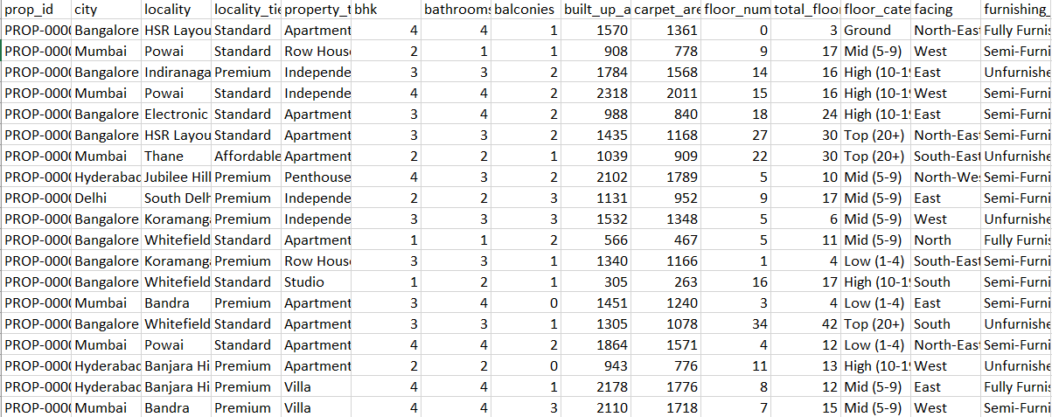
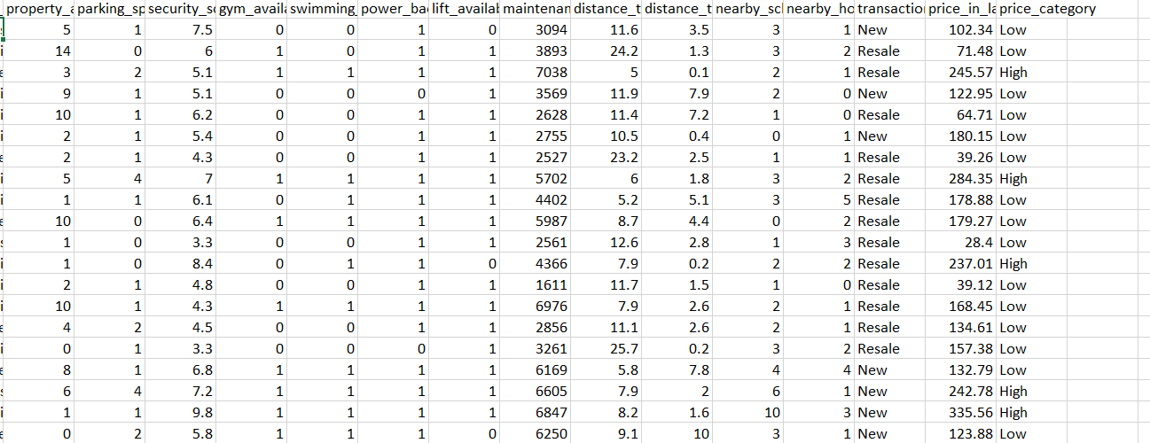

3.4 PROPOSED SYSTEM
The proposed system is developed to predict residential house prices using statistical analysis and supervised machine learning techniques. The system analyzes various property characteristics such as location, property type, built-up area, carpet area, number of bedrooms, bathrooms, property age, parking facilities, furnishing status, nearby amenities, and accessibility factors to estimate the selling price of a house. The proposed system follows a systematic and reproducible workflow to ensure accurate prediction, reliable analysis, and meaningful interpretation of results.
The overall workflow consists of the following stages:

Stage 1: Data Collection and Inspection
A structured housing dataset containing 50,000 residential property records with 30 features is used as the input for the proposed system. The dataset includes various structural, geographical, and neighborhood attributes that influence house prices. Initially, the dataset is inspected to verify data types, identify missing values, detect duplicate records, and ensure overall data consistency. Irrelevant or redundant features are identified and removed wherever necessary to improve the quality of the dataset before analysis.

Stage 2: Exploratory Data Analysis (EDA)
Exploratory Data Analysis is performed to understand the characteristics and distribution of the housing dataset. Various visualization techniques such as histograms, box plots, density plots, scatter plots, violin plots, pair plots, bar charts, and correlation heatmaps are used to identify data distributions, detect outliers, analyze feature relationships, and understand the factors influencing house prices. This stage provides valuable insights into the behavior of different variables and supports effective feature selection.

Stage 3: Data Preprocessing
The dataset is prepared for statistical analysis and machine learning by performing the following preprocessing steps:
- Handling missing values and duplicate records.
- Encoding categorical variables into numerical form.
- Splitting the dataset into training and testing datasets.
- Organizing the dataset into independent features and the target variable.
These preprocessing steps ensure that the dataset is clean, consistent, and suitable for developing accurate prediction models.

Stage 4: Statistical Analysis
Statistical techniques are applied to analyze the relationship between property characteristics and house prices. The study performs:
- Pearson Correlation Analysis to measure the relationship between numerical variables.
- Multiple Linear Regression to analyze the influence of multiple independent variables on house prices.
- One-Way ANOVA to determine significant differences in house prices among different property groups.
- Chi-Square Test to examine the association between categorical variables.
- Principal Component Analysis (PCA) to reduce data dimensionality while preserving important information.
These techniques help identify the most significant variables affecting residential property prices.

Stage 5: Machine Learning Model Development
Five supervised machine learning regression algorithms are implemented to predict house prices:
- Linear Regression
- Decision Tree Regressor
- Random Forest Regressor
- Gradient Boosting Regressor
- XGBoost Regressor
Each model is trained using the prepared training dataset to learn the relationship between the input features and the target variable. The developed models are then tested using unseen data to evaluate their prediction capability.

Stage 6: Model Evaluation and Validation
The performance of all machine learning models is evaluated using standard regression evaluation metrics, including:
- Mean Absolute Error (MAE)
- Mean Squared Error (MSE)
- Root Mean Squared Error (RMSE)
- R² Score
The evaluation results are compared to identify the model that provides the highest prediction accuracy and the lowest prediction error.

Stage 7: Model Interpretation and Result Analysis
To improve transparency and interpretability, the proposed system incorporates SHAP (SHapley Additive exPlanations) for feature importance analysis. SHAP identifies the contribution of each feature to the predicted house price and explains how different property characteristics influence the prediction results. The final output includes predicted house prices, model comparison results, feature importance analysis, and graphical visualizations, enabling buyers, sellers, investors, and real estate professionals to make informed, data-driven decisions.

3.5 SYSTEM ARCHITECTURE

The proposed House Price Prediction System follows a structured architecture that transforms raw housing data into accurate house price predictions through statistical analysis and machine learning techniques. The architecture consists of several interconnected stages, ensuring efficient data processing, model development, and result interpretation.
The process begins with the collection of a housing dataset containing 50,000 residential property records and 30 features. The collected data undergoes preprocessing, including data cleaning, missing value handling, duplicate record removal, and categorical variable encoding. This step improves data quality and prepares the dataset for further analysis.
After preprocessing, Exploratory Data Analysis (EDA) and descriptive statistical analysis are performed to understand the characteristics of the dataset. Various visualization techniques, including histograms, box plots, density plots, scatter plots, violin plots, pair plots, and correlation heatmaps, are used to identify data distributions, relationships among variables, and potential outliers.
The processed dataset is then subjected to statistical analysis using Pearson Correlation Analysis, Multiple Linear Regression, One-Way ANOVA, Chi-Square Test, and Principal Component Analysis (PCA). These techniques help identify the significant factors influencing house prices and validate the research hypotheses.
The prepared data is divided into training and testing datasets. Five machine learning algorithms—Linear Regression, Decision Tree Regressor, Random Forest Regressor, Gradient Boosting Regressor, and XGBoost Regressor—are trained using the training data. The models are evaluated using MAE, MSE, RMSE, and R² Score, and the best-performing model is selected based on its predictive performance.
Finally, SHAP (SHapley Additive exPlanations) is used to interpret the predictions by identifying the contribution of each feature to the predicted house price. The system produces accurate house price predictions along with feature importance analysis, enabling users to understand the factors influencing property values and supporting informed decision-making in the real estate sector.

ARCHITECTURE:

Dataset
↓
Data Preprocessing
(Cleaning, Missing Values, Encoding)
↓
Exploratory Data Analysis
(Visualizations & Statistical Summary)
↓
Statistical Analysis & Testing
(Pearson, Multiple Regression, ANOVA, Chi-Square, PCA)
↓
Feature Selection
↓
Model Training
(• Linear Regression , • Decision Tree Regressor • Random Forest Regressor
• Gradient Boosting Regressor • XGBoost Regressor )
↓
Model Evaluation
(MAE, MSE, RMSE, R² Score)
↓
SHAP Explainable AI Analysis
↓
Prediction & Insights

3.6 DATA PREPROCESSING
Data preprocessing is one of the most important stages in the development of any machine learning model. The accuracy and reliability of prediction models depend significantly on the quality of the input data. Real-world datasets often contain missing values, duplicate records, inconsistent formats, irrelevant features, and categorical variables that cannot be directly processed by machine learning algorithms. Therefore, preprocessing is performed to clean, organize, and transform the data into a suitable format for statistical analysis and predictive modeling.
The housing dataset used in this project contains 50,000 residential property records with 30 features representing various structural, geographical, and neighborhood characteristics of residential properties across major Indian metropolitan cities. The target variable of the dataset is Price in Lakhs, while the remaining variables describe different characteristics of residential properties, including location, property type, built-up area, carpet area, number of bedrooms, bathrooms, balconies, parking spaces, furnishing status, property age, maintenance fee, security score, distance to metro stations, nearby schools, nearby hospitals, and several other property-related attributes.
Since the dataset is collected from publicly available real estate sources, it requires careful preprocessing before applying statistical techniques and machine learning algorithms. The preprocessing stage ensures that the dataset is complete, consistent, reliable, and suitable for predictive analysis. The major preprocessing steps carried out in this study are explained below.

Stage 1: Data Loading and Initial Inspection
The first step of preprocessing involves loading the housing dataset into the Python programming environment using the Pandas library. After importing the dataset, an initial inspection is performed to understand its overall structure. The number of rows, number of columns, variable names, data types, and summary information are examined using built-in functions such as head(), info(), shape, and describe().
This preliminary inspection helps verify that the dataset has been imported correctly and provides an overview of the available information. It also helps identify the presence of numerical and categorical variables, which require different preprocessing techniques before model development.

Stage 2: Missing Value Analysis
Missing values are common in real-world datasets and may reduce the performance of statistical analysis and machine learning models. Therefore, the dataset is examined to identify missing or null values present in each feature.
A missing value analysis is performed using appropriate Python functions to determine whether incomplete observations exist. If missing values are identified, suitable preprocessing methods are applied to ensure the consistency and completeness of the dataset. Handling missing values improves the reliability of the prediction models and prevents inaccurate results during analysis.

Stage 3: Duplicate Record Detection
Duplicate records introduce redundancy into the dataset and may bias statistical analysis and prediction models. During this stage, the housing dataset is checked for duplicate observations using duplicate detection techniques available in the Pandas library.
Any duplicate property records identified in the dataset are removed before further analysis. Eliminating duplicate observations improves the overall quality of the dataset, reduces unnecessary computation, and ensures that each property contributes only once during model training.

Stage 4: Data Type Verification
Each variable in the housing dataset is examined to ensure that it is stored using the appropriate data type. Numerical variables such as built-up area, carpet area, bathrooms, and property age are maintained as numerical values, while categorical variables such as city, locality, property type, furnishing status, and locality tier are identified separately.
Proper data type verification is essential because statistical analysis and machine learning algorithms require numerical input for mathematical computations. Correct data types also improve memory efficiency and computational performance.

Stage 5: Categorical Variable Encoding
The housing dataset contains several categorical variables that represent descriptive information about residential properties. Machine learning algorithms cannot process textual values directly; therefore, these categorical variables are converted into numerical representations through encoding techniques.
Variables such as city, locality, property type, furnishing status, and locality tier are transformed into numerical values using encoding methods. This conversion preserves the information contained in categorical variables while enabling machine learning algorithms to analyze their relationship with house prices effectively.

Stage 6: Feature Selection
Feature selection is performed to identify the most relevant variables required for predicting house prices. During this stage, the target variable Price in Lakhs is separated from the independent variables.
The remaining property characteristics are selected as predictor variables for statistical analysis and machine learning model development. Selecting relevant features helps reduce unnecessary complexity, improves computational efficiency, and enhances prediction accuracy by focusing only on meaningful information.

Stage 7: Train-Test Data Splitting
After preprocessing and feature selection, the dataset is divided into training and testing datasets. The training dataset is used to develop the machine learning models, while the testing dataset is reserved for evaluating the performance of the developed models on unseen data.
The train-test split ensures that the models are evaluated fairly and helps determine their ability to generalize to new housing records. This process minimizes overfitting and provides a realistic estimate of prediction accuracy.

Importance of Data Preprocessing
Data preprocessing plays a vital role in improving the quality of predictive models. Clean and well-structured data enables machine learning algorithms to learn meaningful patterns from the housing dataset more effectively. Proper preprocessing reduces noise, eliminates inconsistencies, improves feature quality, and increases the overall reliability of statistical analysis.
The preprocessing stage also supports accurate exploratory data analysis, hypothesis testing, regression analysis, and machine learning model development. Without appropriate preprocessing, prediction models may generate biased or inaccurate results due to poor data quality.

Summary
The data preprocessing stage transforms the raw housing dataset into a structured and analysis-ready format. Through data loading, missing value analysis, duplicate removal, data type verification, categorical variable encoding, feature selection, and train-test splitting, the dataset becomes suitable for statistical analysis and machine learning. The preprocessed dataset serves as the foundation for all subsequent stages of the proposed system, including Exploratory Data Analysis (EDA), statistical hypothesis testing, regression analysis, model training, model evaluation, and house price prediction.

3.7 MODEL SELECTION AND JUSTIFICATION
The selection of appropriate machine learning algorithms is an important step in developing an accurate and reliable house price prediction system. In this project, five supervised machine learning regression algorithms were selected: Linear Regression, Decision Tree Regressor, Random Forest Regressor, Gradient Boosting Regressor, and XGBoost Regressor. These models were chosen to compare the performance of traditional regression techniques with advanced ensemble learning algorithms and identify the most suitable model for house price prediction.

Linear Regression
Linear Regression was selected as the baseline regression model due to its simplicity, computational efficiency, and interpretability. It establishes a linear relationship between the independent variables and the target variable and provides a benchmark for evaluating the performance of more advanced machine learning models.
The use of Linear Regression allows:
- Evaluation of baseline prediction performance.
- Understanding the linear relationship between property features and house prices.
- Simple interpretation of the influence of independent variables.
- Comparison with advanced machine learning algorithms.

Decision Tree Regressor
Decision Tree Regressor was selected because it can capture both linear and nonlinear relationships without making assumptions about the distribution of the data. It predicts house prices by recursively splitting the dataset based on the most significant features.
Decision Tree Regressor was chosen because:
- It effectively models nonlinear relationships.
- It is easy to understand and interpret.
- It automatically selects important decision rules.
- It performs well on structured housing datasets.

Random Forest Regressor
Random Forest Regressor was selected as an ensemble learning model that combines multiple decision trees to improve prediction accuracy and reduce overfitting. It produces more stable and reliable predictions than a single decision tree.
Random Forest was chosen because:
- It improves prediction accuracy through ensemble learning.
- It reduces overfitting by averaging multiple decision trees.
- It performs effectively on large structured datasets.
- It provides feature importance for identifying influential variables.

Gradient Boosting Regressor
Gradient Boosting Regressor was selected because it builds prediction models sequentially by correcting the errors of previous models. This boosting strategy enables the algorithm to achieve high prediction accuracy by learning complex relationships among property characteristics.
Gradient Boosting was selected because:
- It improves prediction accuracy through sequential learning.
- It effectively captures complex nonlinear relationships.
- It minimizes prediction errors iteratively.
- It performs well for regression problems involving structured data.

XGBoost Regressor
XGBoost (Extreme Gradient Boosting) was selected as an advanced boosting algorithm due to its high computational efficiency and excellent prediction performance. It incorporates regularization techniques that improve model generalization and reduce overfitting.
XGBoost was chosen because:
- It provides high prediction accuracy.
- It efficiently handles large housing datasets.
- It reduces overfitting using regularization techniques.
- It is one of the most widely used algorithms for regression problems.

Model Comparison Strategy
All five machine learning models are trained using the same preprocessed training dataset and evaluated using the same testing dataset. Their performance is compared using standard regression evaluation metrics such as Mean Absolute Error (MAE), Mean Squared Error (MSE), Root Mean Squared Error (RMSE), and R² Score.
The comparative analysis helps to:
- Compare the performance of different regression algorithms.
- Identify the model with the highest prediction accuracy.
- Evaluate the prediction error of each model.
- Select the most suitable model for house price prediction.
- Ensure that the final model is chosen based on objective performance evaluation rather than assumptions.
This comparative approach improves the reliability of the proposed system and ensures that the selected prediction model provides accurate, consistent, and data-driven house price estimates.

4. DATA ANALYSIS AND RESULTS

4.1 IMPORTING LIBRARIES AND LOADING DATASET
The implementation begins with importing the necessary Python libraries required for data manipulation, visualization, and analysis.
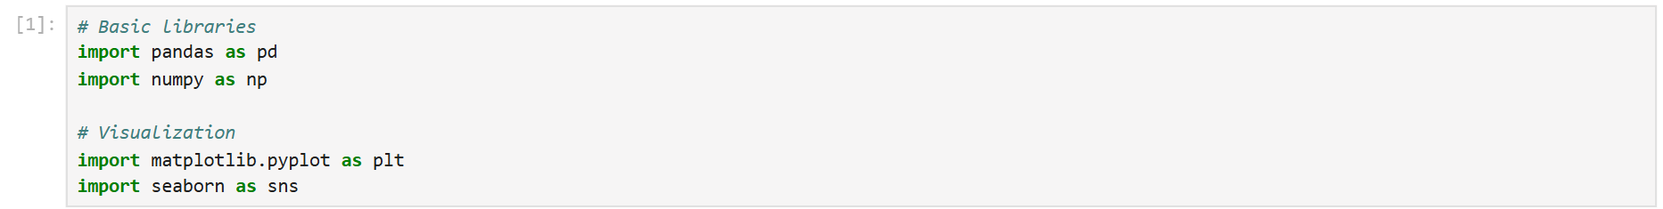
The Pandas library is used for handling structured data, reading the dataset, and performing preprocessing operations.
NumPy supports numerical computations.
For visualization purposes, Matplotlib and Seaborn are imported to generate graphical representations of behavioral patterns and mental state distributions.
The housing dataset is loaded into the Python environment using the read_csv() function provided by the Pandas library. The dataset is stored in a DataFrame named df, which is used for data preprocessing, statistical analysis, visualization, and machine learning model development throughout the project.
• pd.read_csv() imports the CSV dataset into Python.
• The dataset is stored in the df DataFrame for further analysis and model building.

.

4.2 UNDERSTANDING THE DATA

4.2.1 Dataset Dimension
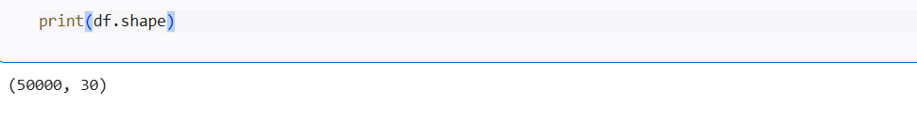
The dimensions of the housing dataset were examined using the shape attribute. The dataset contains 50,000 residential property records and 30 features before preprocessing. This confirms that the dataset is sufficiently large for performing exploratory data analysis, statistical analysis, and machine learning modeling. The features include structural, geographical, and neighborhood characteristics that influence residential property prices.

4.2.2 Initial Data Inspection:
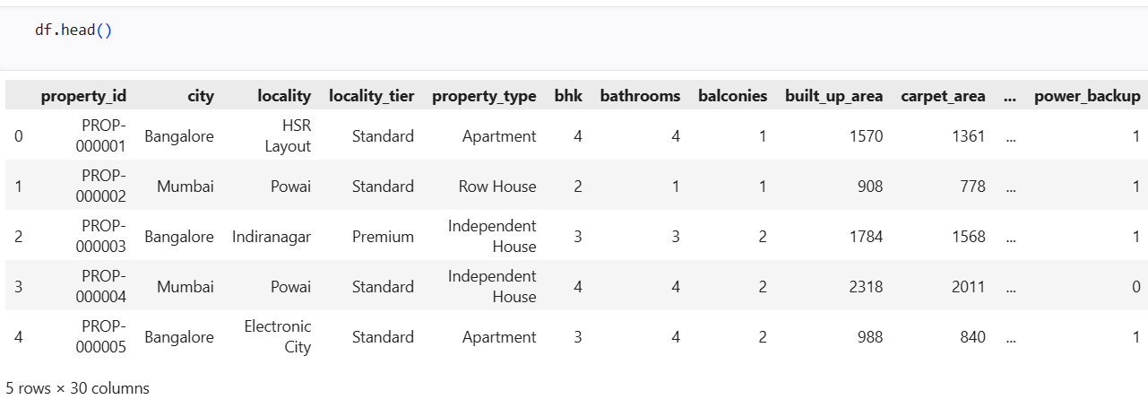
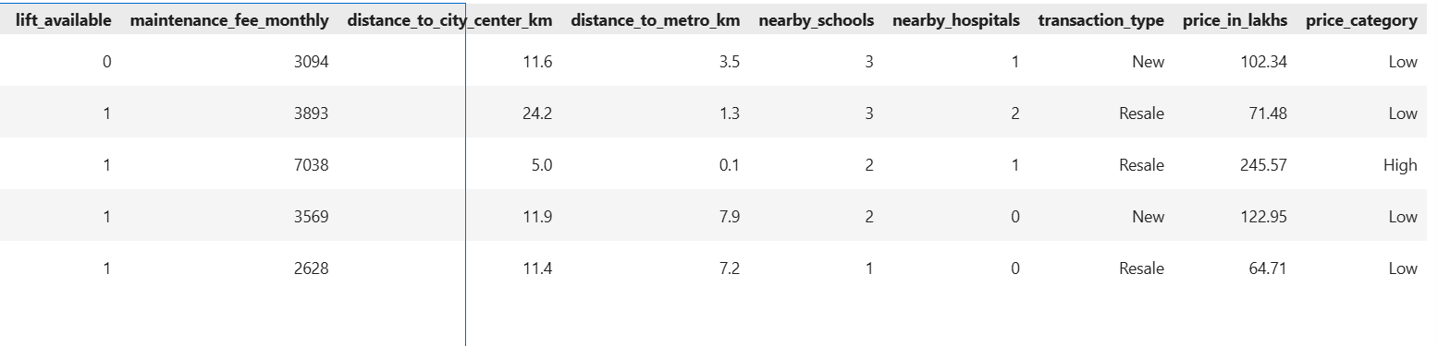
The date column was converted into a proper datetime format to ensure consistency in data representation. The first few rows of the dataset were displayed using the head() function to verify the structure and confirm correct loading.

This inspection confirms that the dataset is structured and organized in a tabular format suitable for machine learning analysis.
The displayed records confirm that the dataset contains both categorical variables (such as city, locality, locality tier, and property type) and numerical variables (such as built-up area, carpet area, bedrooms, bathrooms, and balconies). This initial inspection helps verify that the dataset has been loaded correctly and provides an understanding of the different attributes available for house price prediction.

4.2.3 Missing Value Analysis:
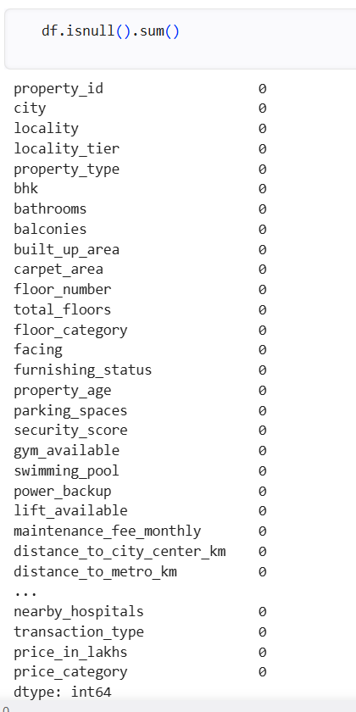
Before performing exploratory analysis and model training, the dataset was examined for missing or null values using the isnull().sum() function.
The analysis revealed that none of the attributes contain missing values. All columns have complete data across 50000 records.
• Total Missing Values: 0
• Missing Values in Each Feature: 0

Interpretation
- The missing value analysis shows that no null values are present in any of the 30 features.
- The dataset is complete and consistent, with all records containing valid information.
- No missing value imputation or data removal is required before analysis.
- The high quality of the dataset improves the reliability of statistical analysis and machine learning models.
- The dataset is ready for the next stage of preprocessing, exploratory data analysis (EDA), and model development.
.
4.2.4 Duplicate Record Analysis:

The dataset was examined for duplicate records using the duplicated().sum() function.

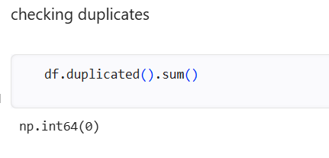

• The duplicate record analysis shows that no duplicate records are present in the dataset.
• Each property record is unique and represents a distinct residential property.
• No duplicate data removal is required before further analysis.
• The absence of duplicate records improves the quality and reliability of the dataset.
• The dataset is suitable for exploratory data analysis, statistical analysis, and machine learning model development.
4.2.5 Dataset Structure and Data Types:
The dataset information was examined using the info() function to obtain details about the dataset structure, including the total number of records, number of features, data types, and non-null values.

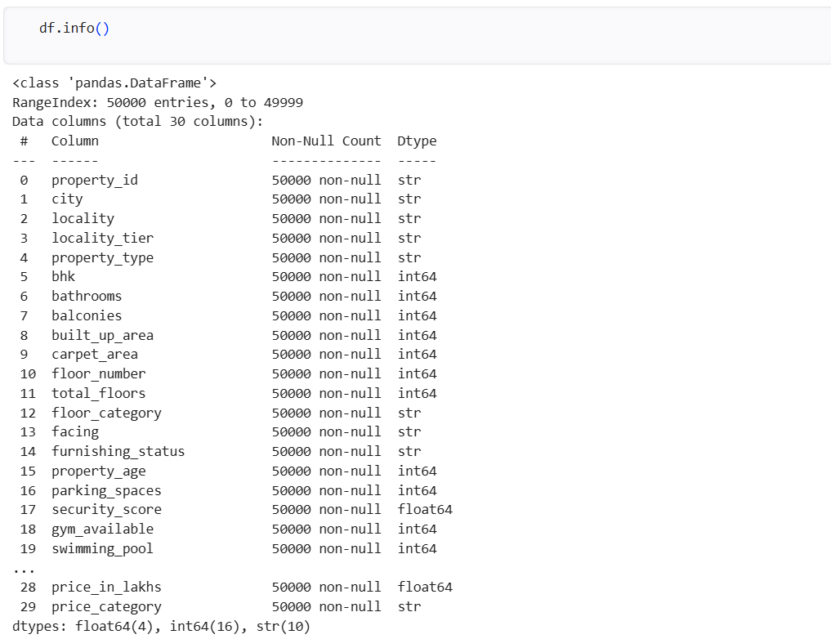
The structure of the dataset was examined using the info() function to understand the number of attributes, data types, and memory usage.
• Total Records: 50,000
• Total Features: 30
• Non-Null Values: 50,000 for all features
• Data Types:
- Integer (int64): 16 features
- Float (float64): 4 features
- String (object/str): 10 features
- • All features have 50,000 non-null values, indicating that the dataset is complete.
- • The dataset includes a combination of numerical and categorical variables.
- • Numerical variables are suitable for statistical analysis and machine learning computations.
- • Categorical variables will be encoded during the preprocessing stage before model training.
- • The dataset structure is consistent and ready for further exploratory data analysis, statistical analysis, and machine learning model development.

4.2.6 Dropping irrelevant features :
The property_id column was removed from the dataset before model development because it serves only as a unique identifier for each property and does not contain meaningful information for predicting house prices.
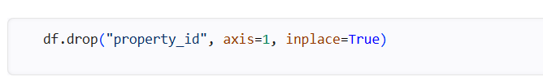
• The property_id column was removed from the dataset.
• It is a unique identifier and does not influence house price prediction.
• Removing irrelevant attributes reduces unnecessary computation.
• It helps improve the efficiency of statistical analysis and machine learning models.
• The dataset now contains only meaningful features for further preprocessing and model developme

4.2.7 Statistical Summary of Numerical Features:
Descriptive statistical analysis was performed using the describe() function to understand the distribution, central tendency, and variability of numerical features in the dataset.
The summary statistics include:
Count, Mean, Standard Deviation, Minimum value, 25th percentile (Q1), Median (Q2), 75th percentile (Q3), Maximum value.
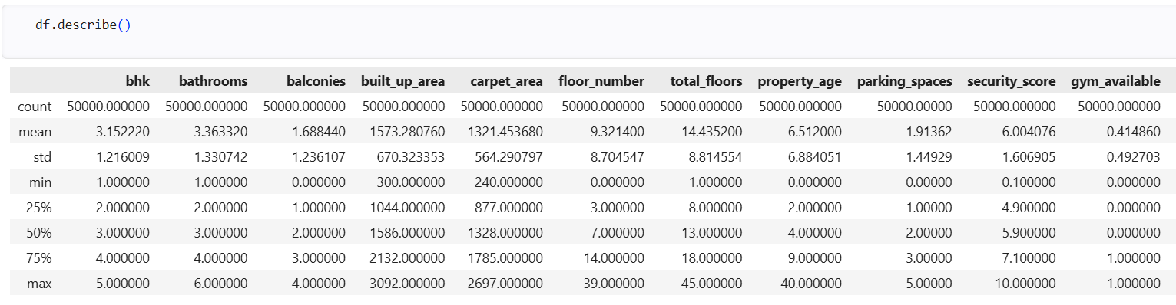

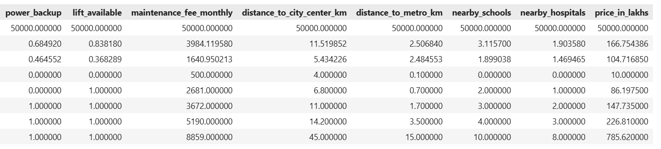
Interpretation of Summary Statistics

• The statistical summary is computed for all numerical features in the dataset.
• Each numerical feature contains 50,000 observations, indicating complete data.
• The mean represents the average value of each variable.
• The standard deviation measures the variability or spread of the data.
• The minimum and maximum values indicate the range of each feature.
• The 25th, 50th (median), and 75th percentiles describe the distribution of the data.
• The target variable price_in_lakhs has an average value of approximately 166.75 lakhs, with prices ranging from 10 lakhs to 785.62 lakhs.
These insights provide a strong foundation for further exploratory data analysis and predictive modeling.

4.2.8 Statistical Hypothesis Testing:

Pearson Correlation Analysis:

Pearson Correlation Analysis was performed to measure the strength and direction of the linear relationship between the carpet area and house price (price_in_lakhs). The Pearson correlation coefficient ranges from -1 to +1, where values close to +1 indicate a strong positive relationship, values close to -1 indicate a strong negative relationship, and values close to 0 indicate no linear relationship.

Hypothesis
Null Hypothesis (H₀):
Carpet area has no significant relationship with house price.
Alternative Hypothesis (H₁):
Carpet area has a significant relationship with house price.

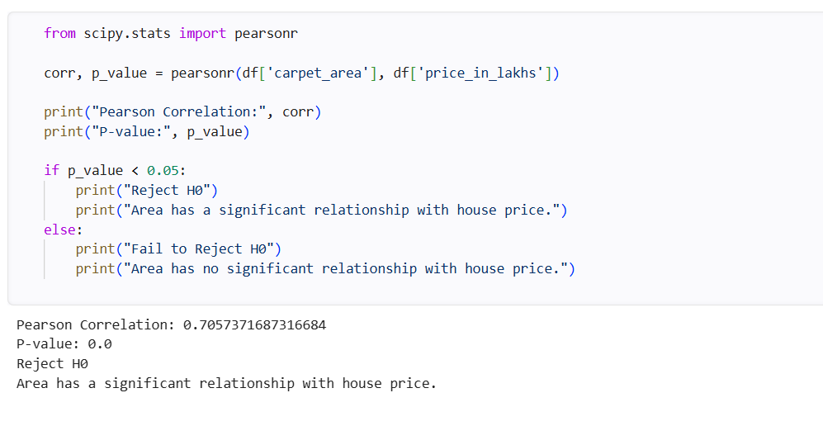

• Pearson Correlation Coefficient: 0.7057
• P-value: 0.0000
• Decision: Reject H₀
• The Pearson correlation coefficient (0.7057) indicates a strong positive relationship between carpet area and house price.
• The p-value (0.0000) is less than the significance level of 0.05.
• Therefore, the null hypothesis (H₀) is rejected.
• The results confirm that carpet area has a statistically significant influence on house price.

2.ANOVA Test (City vs House Price)

One-Way Analysis of Variance (ANOVA) was performed to determine whether there is a statistically significant difference in house prices among different cities. ANOVA compares the mean house prices of multiple groups and determines whether the observed differences are statistically significant. The significance of the test is evaluated using the F-statistic and p-value at a significance level of 0.05.

Hypothesis

Null Hypothesis (H₀):
There is no significant difference in house prices across different cities.
Alternative Hypothesis (H₁):
There is a significant difference in house prices across different cities
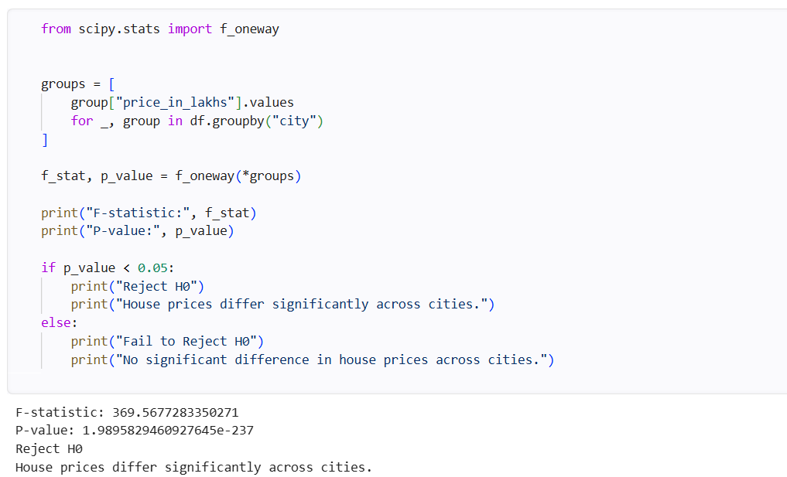

• F-statistic: 369.5677
• P-value: 1.9896 × 10⁻²³⁷
• Decision: Reject H₀.
• The F-statistic (369.5677) indicates a substantial variation in average house prices among the cities.
• The p-value (1.9896 × 10⁻²³⁷) is much smaller than the significance level of 0.05.

• Therefore, the null hypothesis (H₀) is rejected.

The One-Way ANOVA test demonstrates that the average house prices are not the same across all cities.

3. Chi-Square Test(city vs property type)

The Chi-Square Test of Independence was performed to determine whether there is a significant association between city and property type. The significance of the association is determined using the Chi-Square statistic and the p-value at a significance level of 0.05.

Hypothesis
Null Hypothesis (H₀):
Carpet area has no significant relationship with house price.
Alternative Hypothesis (H₁):
Carpet area has a significant relationship with house price.
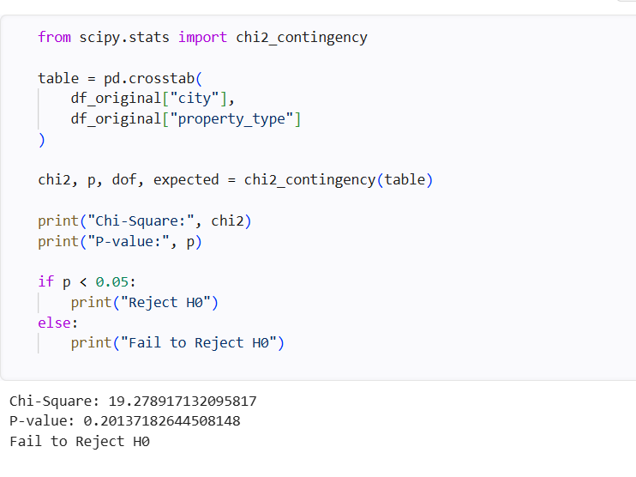
• Chi-Square Statistic: 19.2789
• P-value: 0.2014
• Decision: Fail to Reject H₀
• The Chi-Square statistic is 19.2789, indicating the observed difference between the actual and expected frequencies.
• The p-value (0.2014) is greater than 0.05, indicating that the association is not statistically significant.
• Therefore, the null hypothesis (H₀) is not rejected.
• The results indicate that city and property type are statistically independent in this dataset.
• This suggests that the distribution of property types is similar across the selected cities.
In this project, class weighting and stratified sampling were used to handle imbalance during model training.

Exploratory Data Analysis
4.2.9 House Price Distribution
a histogram is used to examine the distribution of house prices (price_in_lakhs) and understand how residential property prices are distributed across the housing dataset.
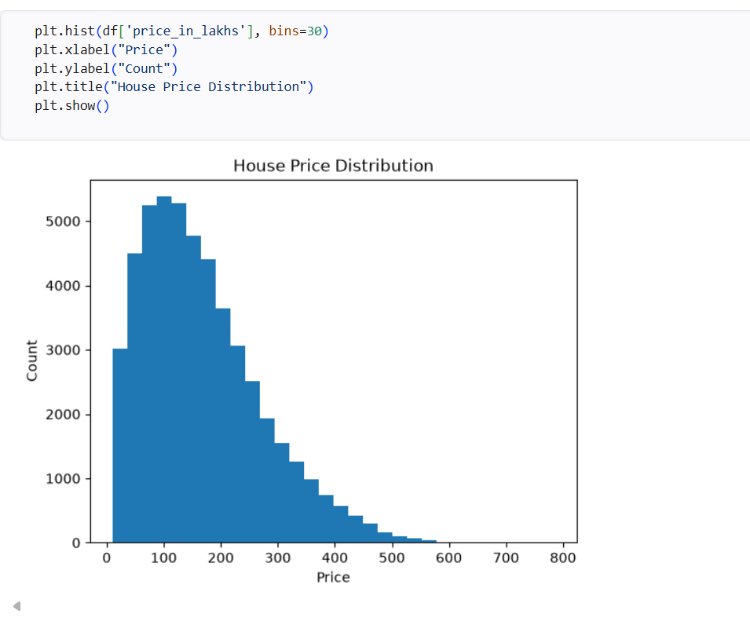
• The histogram shows the distribution of house prices in the dataset.
• Most residential properties are concentrated in the lower and medium price ranges.
• The distribution is positively (right) skewed, with a long tail extending toward higher prices.
• Only a small number of properties belong to the high-price segment, indicating the presence of luxury properties.
• The distribution suggests that moderately priced houses are more common than expensive houses in the dataset.

4.2.10 City wise Price Analysis:

A box plot is a statistical visualization used to summarize the distribution of a numerical variable across different categories. It displays the minimum value, first quartile (Q1), median, third quartile (Q3), maximum value, and potential outliers.
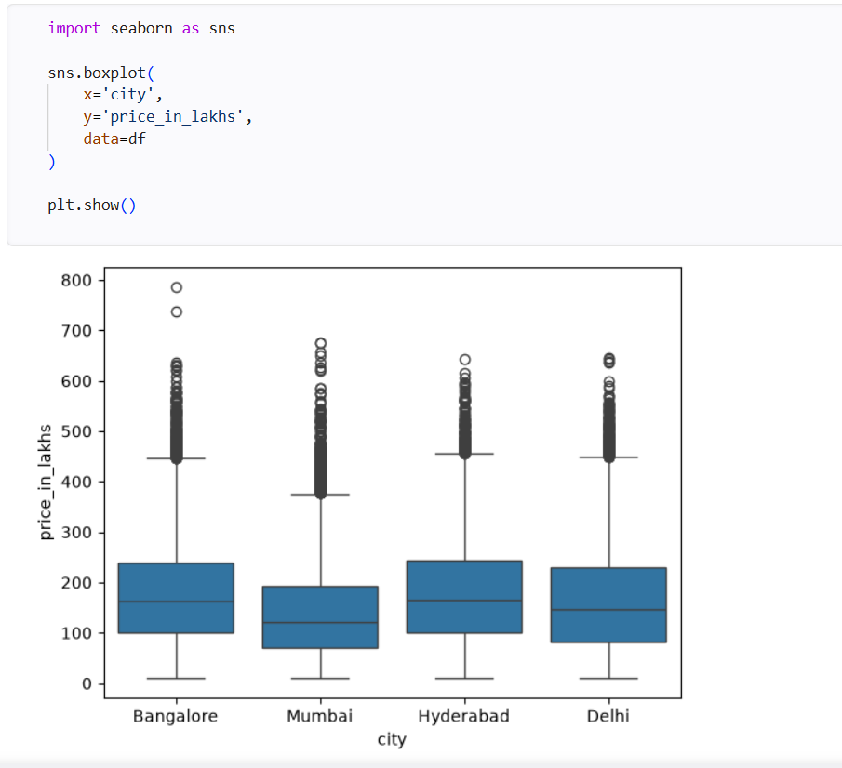

Interpretation
• The box plot compares the distribution of house prices across Bangalore, Mumbai, Hyderabad, and Delhi.
• The median house price differs across the cities, indicating variations in property values.
• All cities contain several outliers, representing high-value residential properties.
• The spread of the boxes indicates that house prices vary considerably within each city.
• Hyderabad and Bangalore show relatively higher median prices compared to Mumbai, while Delhi also exhibits a wide range of property prices.
• The presence of outliers suggests that luxury and premium properties exist in all four cities.

4.2.11 Number Of Bedrooms(BHK) vs House Price
A scatter plot is used to examine the relationship between two numerical variables. It helps identify trends, patterns, and the strength of association between the number of bedrooms (BHK) and house price.

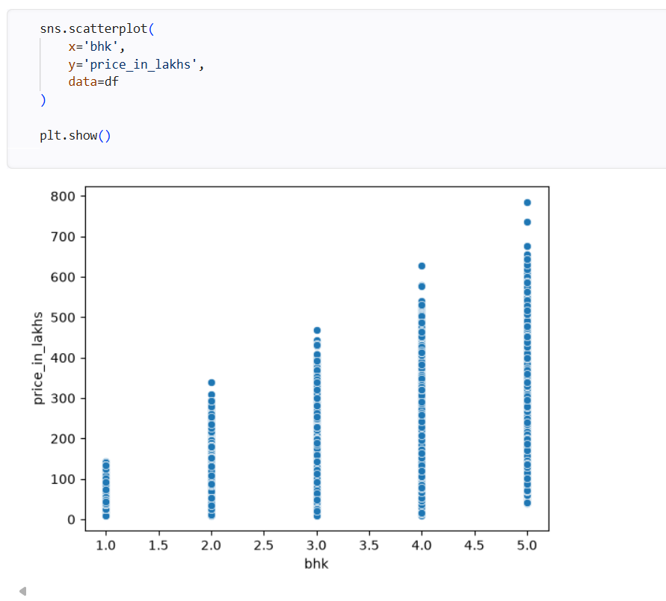

Interpretation
- Houses with 1 BHK are generally priced between ₹10 lakhs and ₹140 lakhs.
- 2 BHK properties are mostly priced up to ₹340 lakhs.
- 3 BHK houses range approximately from ₹20 lakhs to ₹470 lakhs.
- 4 BHK properties reach prices of around ₹630 lakhs.
- 5 BHK houses have the highest prices, reaching approximately ₹785 lakhs.
- The scatter plot indicates a positive relationship between the number of bedrooms and house price.
4.2.10 Built-Up-Area vs Price
The scatter plot is used to analyze the relationship between built-up area and house price.

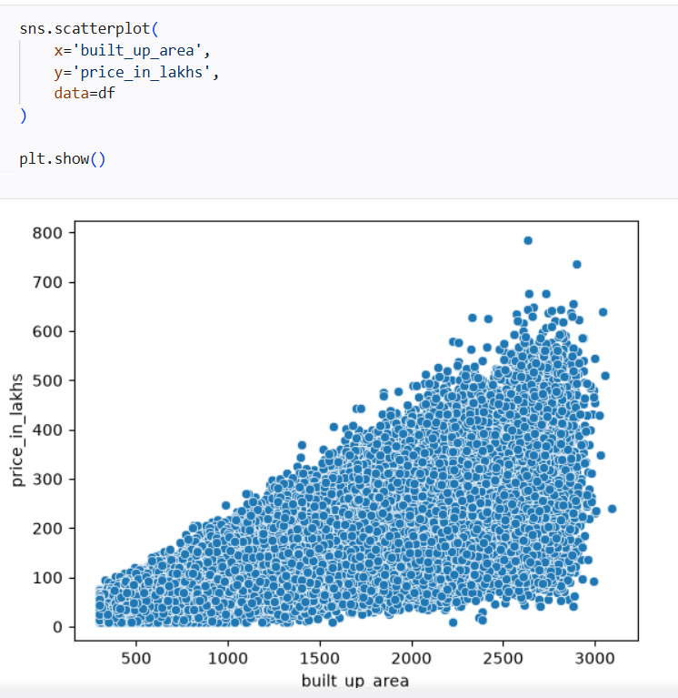

Interpretation
- The built-up area ranges from approximately 300 sq.ft. to 3,100 sq.ft.
- House prices range from approximately ₹10 lakhs to ₹785 lakhs.
- Most properties are concentrated between 800–2,800 sq.ft. with prices ranging from ₹100 lakhs to ₹500 lakhs.
- As the built-up area increases, the house price generally increases, indicating a positive relationship.
- A few high-priced properties (above ₹600 lakhs) are observed for larger built-up areas, representing premium residential properties.
4.2.12 Average House Price by City

Compared the average residential property prices across the four metropolitan cities in the dataset.

====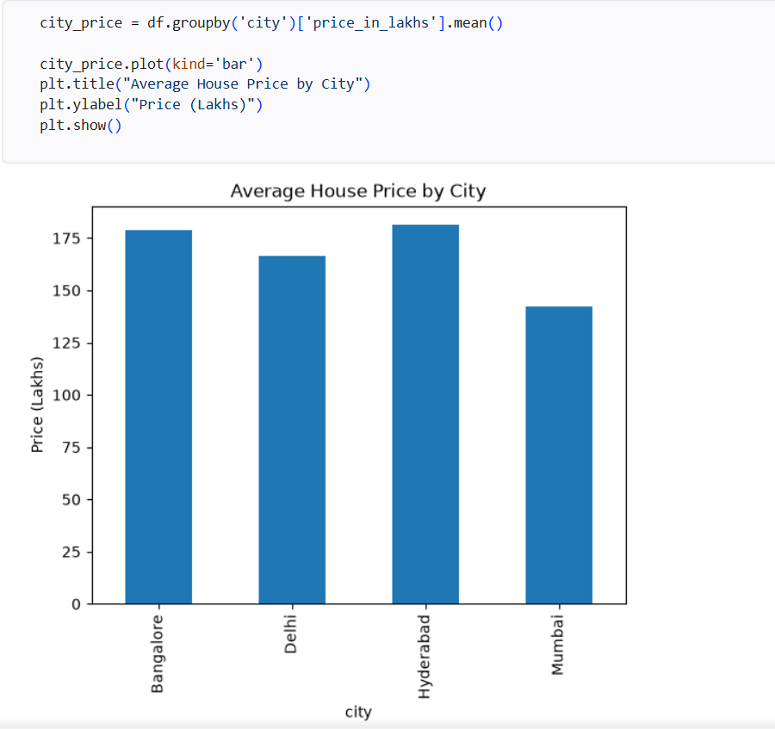

Interpretation
- Hyderabad has the highest average house price at approximately ₹181 lakhs.
- Bangalore follows with an average house price of around ₹178 lakhs.
- Delhi has an average house price of approximately ₹166 lakhs.
- Mumbai has the lowest average house price at around ₹142 lakhs.
- The variation in average prices indicates that location (city) significantly influences residential property values.

4.2.13 Correlation Heatmap Analysis:

Correlation values range from -1 to +1, where values close to +1 indicate a strong positive relationship, values close to -1 indicate a strong negative relationship, and values near 0 indicate little or no linear relationship.

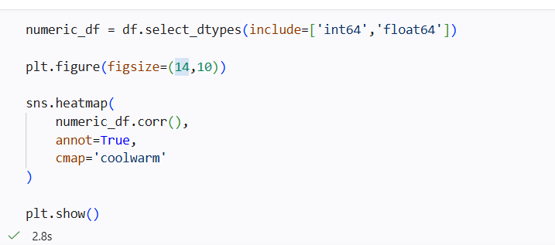
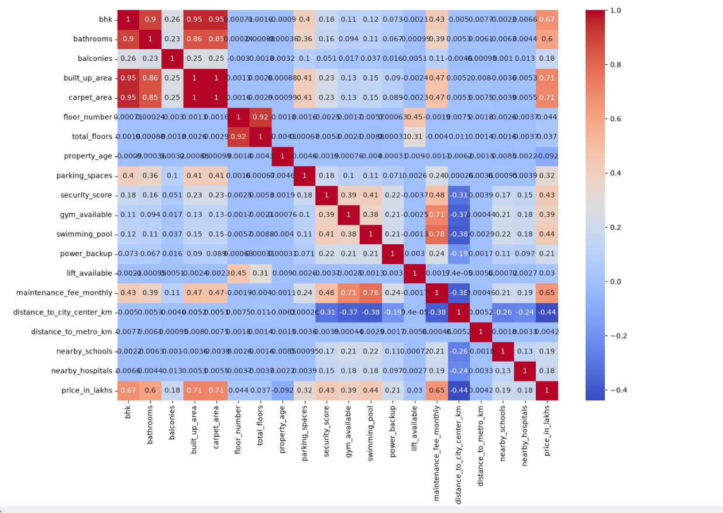

Interpretation
- Built-up Area has a strong positive correlation (0.71) with house price.
- Carpet Area also shows a strong positive correlation (0.71) with house price.
- BHK has a positive correlation (0.67) with house price.
- Maintenance Fee has a moderate positive correlation (0.65) with house price.
- Bathrooms have a positive correlation (0.60) with house price.
- Distance to City Center has a moderate negative correlation (-0.44), indicating that properties farther from the city center generally have lower prices.
- Most other variables show weak to moderate correlations, suggesting they have a smaller influence on house prices.
4.2.14 Top Locations:
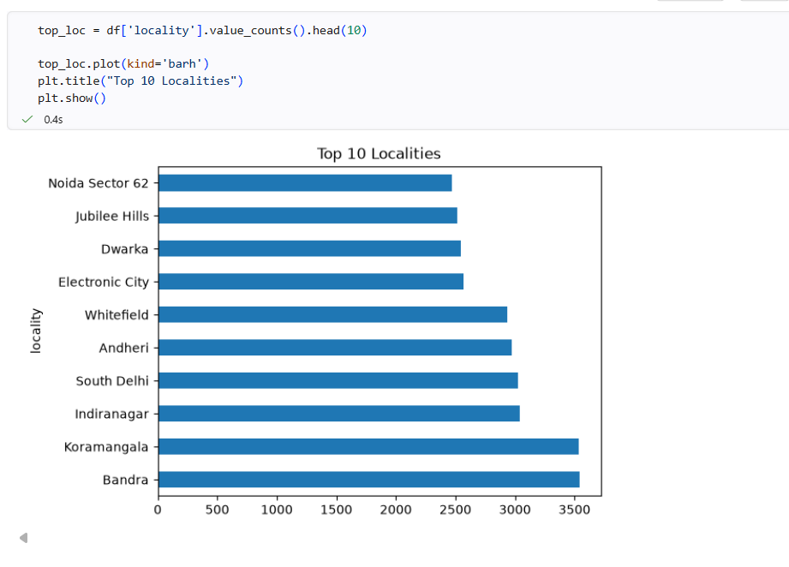
• Bandra and Koramangala have the highest number of residential property listings, with approximately 3,500 properties each.
• Indiranagar, South Delhi, and Andheri each have around 3,000 property listings.
• Whitefield contains approximately 2,900 residential properties.
• Electronic City, Dwarka, Jubilee Hills, and Noida Sector 62 each have approximately 2,500–2,600 property listings.

4.3 MODEL DEVELOPMENT

4.3.1 Encoding Categorical Variables:
Before developing machine learning models, the dataset was prepared by separating the target variable from the independent variables. The target variable price_in_lakhs was selected as the dependent variable (y), while all remaining features were used as predictor variables (X).
Since the dataset contains several categorical variables such as city, locality, property type, locality tier, facing, furnishing status, transaction type, and price category, these variables were converted into numerical form using One-Hot Encoding. The get_dummies() function was used with the drop_first=True option to avoid multicollinearity by removing one dummy variable from each category.
This preprocessing step enables machine learning algorithms to process categorical data efficiently and improves the overall prediction performance.

4.3.2 Feature Selection and Target Variable:
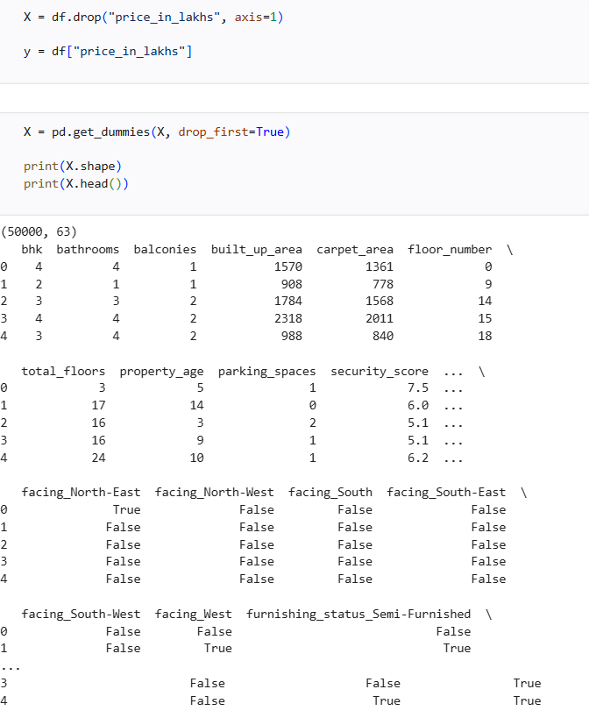
• The target variable price_in_lakhs was separated from the predictor variables.
• Categorical variables were converted into numerical features using One-Hot Encoding.
• The number of predictor variables increased from 29 to 63 after encoding.
• The drop_first=True option was used to reduce redundant dummy variables and prevent multicollinearity.
• The encoded dataset is now suitable for machine learning model training and evaluation.
4.3.3 Train–Test Split:

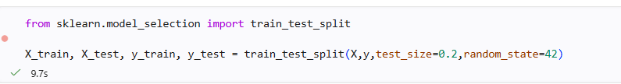

Dataset Splitting :The dataset was divided into
1. Independent Variables (X): Property characteristics used for predicting house prices.
- City
- Locality
- Locality Tier
- Property Type
- BHK
- Bathrooms
- Balconies
- Built-up Area
- Carpet Area
- Floor Number
- Total Floors
- Floor Category
- Facing
- Furnishing Status
- Property Age
- Parking Spaces
- Security Score
- Gym Available
- Swimming Pool
- Power Backup
- Lift Available
- Maintenance Fee (Monthly)
- Distance to City Center
- Distance to Metro
- Nearby Schools
- Nearby Hospitals
- Transaction Type
- Price Category
Categorical variables were converted into numerical format using One-Hot Encoding, increasing the total number of predictor features from 29 to 63.
2. Dependent Variable (y):
- Price in Lakhs
The Price in Lakhs variable serves as the target variable for the regression models. It represents the selling price of residential properties, which is predicted using the selected property features.

• Total Dataset Size: 50,000 records
• Training Data: 40,000 records (80%)
• Testing Data: 10,000 records (20%)
• Random State: 42.

4.3.4 Importing Machine Learning Libraries:
To develop and evaluate the house price prediction models, the required machine learning libraries were imported from the Scikit-learn and XGBoost packages. These libraries provide tools for data preprocessing, dataset splitting, regression model development, and performance evaluation. Importing these libraries is an essential step before training and comparing different machine learning algorithms.
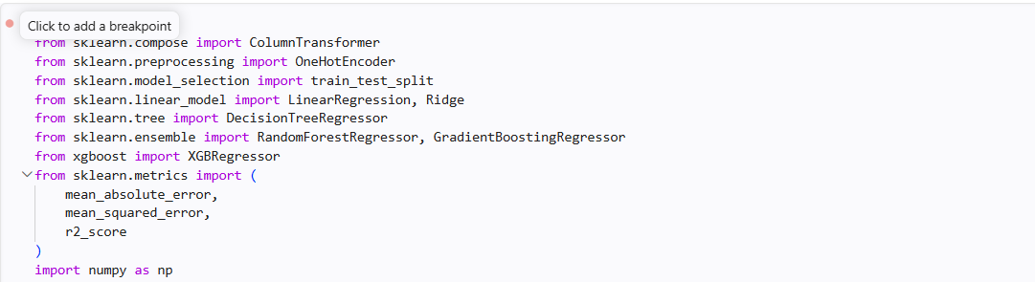

Description of Imported Libraries
- ColumnTransformer – Applies preprocessing to selected columns.
- OneHotEncoder – Converts categorical variables into numerical format.
- train_test_split – Splits the dataset into training and testing sets.
- LinearRegression – Implements the Linear Regression model.
- DecisionTreeRegressor – Builds the Decision Tree regression model.
- RandomForestRegressor – Implements the Random Forest regression model.
- GradientBoostingRegressor – Builds the Gradient Boosting regression model.
- XGBRegressor – Implements the XGBoost regression algorithm.
- Evaluation Metrics – Calculates MAE, MSE, and R² Score to assess model performance.
- NumPy – Performs numerical and mathematical operations.
4.3.5 Linear Regression and Model Evelution:

Linear Regression is one of the most widely used supervised machine learning algorithms for regression problems. It predicts the target variable by establishing a linear relationship between the independent variables and the dependent variable. In this project, Linear Regression is used as the baseline model to predict house prices based on various property characteristics.

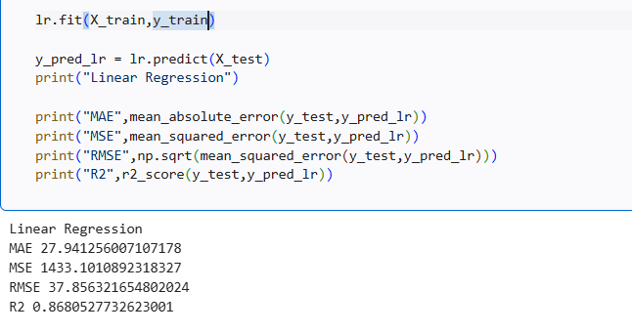
After training the Linear Regression model, its performance was evaluated using the following regression metrics:
- Mean Absolute Error (MAE)
- Mean Squared Error (MSE)
- Root Mean Squared Error (RMSE)
- R² Score

Model Performance
The Linear Regression model achieved:
- MAE = 27.94
- MSE = 1433.10
- RMSE = 37.86
- R² Score = 0.8681
The model explains approximately 86.81% of the variation in house prices, indicating good prediction performance.

Performance Breakdown
Mean Absolute Error (MAE)
- MAE = 27.94 Lakhs
- On average, the predicted house price differs from the actual house price by approximately ₹27.94 lakhs.
- A lower MAE indicates better prediction accuracy.
Mean Squared Error (MSE)
- MSE = 1433.10
- MSE measures the average squared difference between the actual and predicted house prices.
- Larger prediction errors receive greater penalties because the errors are squared.
Root Mean Squared Error (RMSE)
- RMSE = 37.86 Lakhs
- RMSE represents the prediction error in the original unit (Lakhs).
- It indicates that the model's predictions differ from the actual prices by about ₹37.86 lakhs on average.
R² Score
- R² Score = 0.8681
- The model explains approximately 86.81% of the variability in house prices.
- The remaining 13.19% of the variation is due to factors not captured by the model.

Model Evaluation Summary
- The model achieved a good R² Score of 0.8681.
- The prediction errors (MAE and RMSE) are reasonably low for a large housing dataset.
- Linear Regression serves as an effective baseline model for comparing advanced machine learning algorithms.
- Although the model performs well, it may not capture complex nonlinear relationships among property features.

4.3.6 Decision Tree – Model Evaluation: 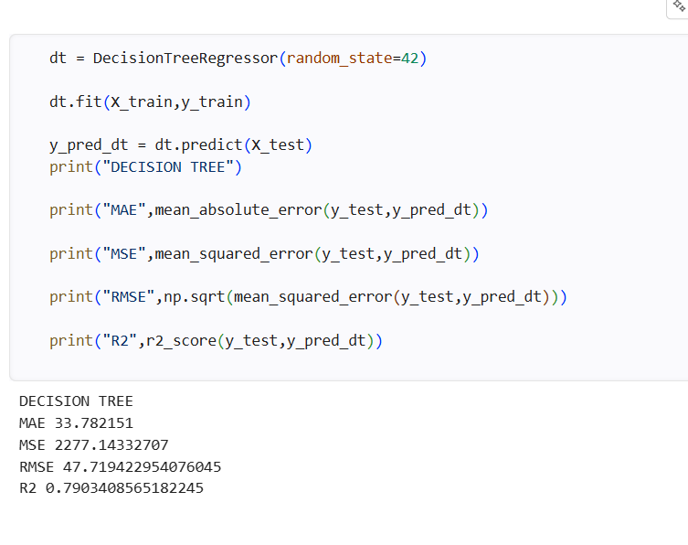

After training the Decision Tree Regressor, the model performance was evaluated using:
- Mean Absolute Error (MAE)
- Mean Squared Error (MSE)
- Root Mean Squared Error (RMSE)
- R² Score

Model Performance
The model achieved:
- MAE = 33.78
- MSE = 2277.14
- RMSE = 47.72
- R² Score = 0.7903
The model explains approximately 79.03% of the variation in house prices.
Mean Absolute Error (MAE):
- MAE = 33.78 Lakhs
- On average, the predicted house price differs from the actual house price by ₹33.78 lakhs.
- A lower MAE indicates better prediction performance.

Mean Squared Error (MSE):
- MSE = 2277.14
- Measures the average squared difference between the actual and predicted house prices.
- Higher values indicate larger prediction errors.

Root Mean Squared Error (RMSE):
- RMSE = 47.72 Lakhs
- Represents the prediction error in the original unit (Lakhs).
- Indicates that the model predictions differ from the actual prices by approximately ₹47.72 lakhs on average.

R² Score:
- R² Score = 0.7903
- The model explains approximately 79.03% of the variation in house prices.
- The remaining 20.97% of the variation is influenced by other factors not captured by the model.

Overall Performance
- The Decision Tree model captures nonlinear relationships between property features and house prices.
- The model achieved moderate prediction accuracy with an R² Score of 0.7903.
- Compared with Linear Regression, the Decision Tree model produced higher prediction errors (MAE and RMSE).
- The model may be prone to overfitting, which can reduce its performance on unseen data.

4.3.7 Random Forest– Model Evaluation:
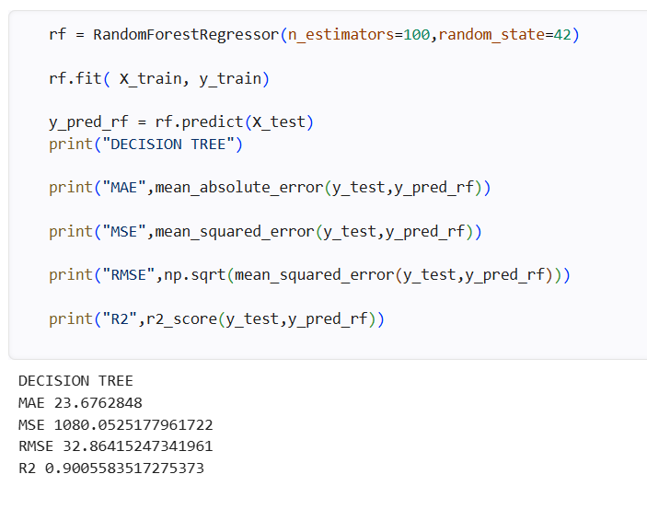

After training the Random Forest Regressor, the model performance was evaluated using the following regression metrics:
- Mean Absolute Error (MAE)
- Mean Squared Error (MSE)
- Root Mean Squared Error (RMSE)
- R² Score

Model Performance
The model achieved:
- MAE = 23.68
- MSE = 1080.05
- RMSE = 32.86
- R² Score = 0.9006
The model explains approximately 90.06% of the variation in house prices, indicating excellent prediction performance.

Performance Breakdown
Mean Absolute Error (MAE):
- MAE = 23.68 Lakhs
- On average, the predicted house price differs from the actual house price by ₹23.68 lakhs.
- The lower MAE indicates that the model produces highly accurate predictions.

Mean Squared Error (MSE):
- MSE = 1080.05
- The model has a lower squared prediction error compared to Linear Regression and Decision Tree.
- A lower MSE indicates improved prediction accuracy.

Root Mean Squared Error (RMSE):
- RMSE = 32.86 Lakhs
- The model's predictions differ from the actual house prices by approximately ₹32.86 lakhs on average.
- The lower RMSE demonstrates better prediction performance.

R² Score:
- R² Score = 0.9006
- The model explains approximately 90.06% of the variation in house prices.
- Only 9.94% of the variation remains unexplained.
Interpretation:
• The Random Forest model achieved an R² Score of 0.9006, indicating excellent predictive performance.
• The MAE, MSE, and RMSE values are significantly lower than those of the Linear Regression and Decision Tree models.
• The ensemble learning approach effectively captures both linear and nonlinear relationships in the housing dataset.
• The model reduces overfitting by combining predictions from multiple decision trees, resulting in more stable and reliable predictions.

4.3.8 Gradient Boosting Model- Model Evalution Summary:
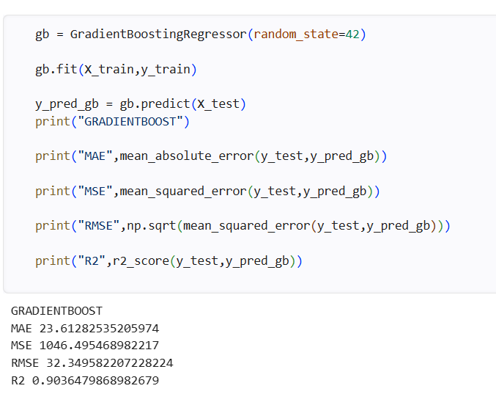

After training the Gradient Boosting Regressor, the model performance was evaluated using the following regression metrics:
- Mean Absolute Error (MAE)
- Mean Squared Error (MSE)
- Root Mean Squared Error (RMSE)
- R² Score

Model Performance
The model achieved:
- MAE = 23.61
- MSE = 1046.50
- RMSE = 32.35
- R² Score = 0.9036
The model explains approximately 90.36% of the variation in house prices, indicating excellent prediction performance.

Performance Breakdown
Mean Absolute Error (MAE):
- MAE = 23.61 Lakhs
- On average, the predicted house price differs from the actual house price by ₹23.61 lakhs.
- This is the lowest MAE among the models evaluated so far, indicating very high prediction accuracy.

Mean Squared Error (MSE):
- MSE = 1046.50
- The model produces a lower squared prediction error than Linear Regression, Decision Tree, and Random Forest.
- A lower MSE indicates better overall model performance.

Root Mean Squared Error (RMSE):
- RMSE = 32.35 Lakhs
- The model's predictions differ from the actual house prices by approximately ₹32.35 lakhs on average.
- This is the lowest RMSE among the evaluated models, demonstrating excellent prediction capability.

R² Score:
- R² Score = 0.9036
- The model explains approximately 90.36% of the variation in house prices.
- Only 9.64% of the variation remains unexplained.

Overall Performance
- The Gradient Boosting model achieved the highest R² Score (0.9036) among the evaluated models.
- The MAE, MSE, and RMSE values are the lowest, indicating superior prediction accuracy.
- The sequential boosting approach effectively minimizes prediction errors by correcting mistakes made by previous models.
- The model successfully captures complex nonlinear relationships among property features, resulting in highly accurate house price predictions.
The Gradient Boosting Regressor is the best-performing model in this study, achieving an R² Score of 0.9036 with the lowest prediction errors (MAE = 23.61, RMSE = 32.35).

4.3.9 XGBoost Regressor – Model Evaluation:

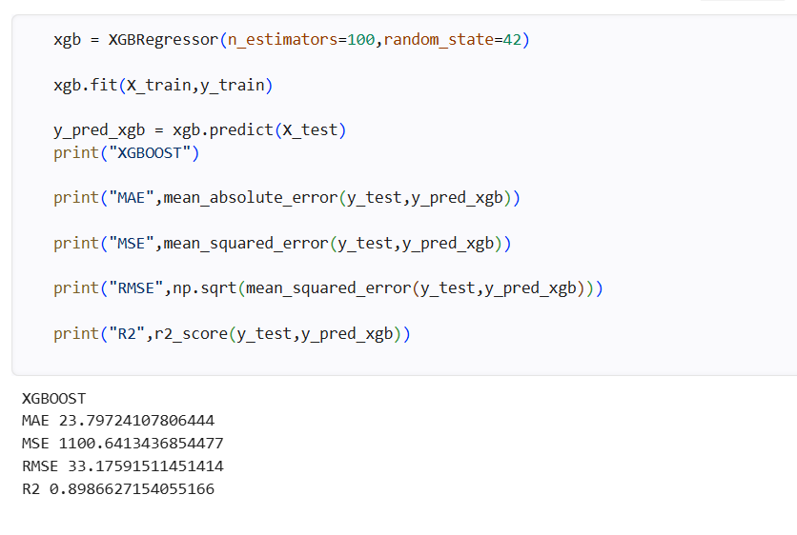

After training the XGBoost Regressor, the model performance was evaluated using the following regression metrics:
- Mean Absolute Error (MAE)
- Mean Squared Error (MSE)
- Root Mean Squared Error (RMSE)
- R² Score

Model Performance
The model achieved:
- MAE = 23.80
- MSE = 1100.64
- RMSE = 33.18
- R² Score = 0.8987
The model explains approximately 89.87% of the variation in house prices, indicating excellent prediction performance.

Performance Breakdown
Mean Absolute Error (MAE):
- MAE = 23.80 Lakhs
- On average, the predicted house price differs from the actual house price by ₹23.80 lakhs.
- The low MAE indicates that the model produces accurate house price predictions.

Mean Squared Error (MSE):
- MSE = 1100.64
- The model has a relatively low squared prediction error.
- Lower MSE values indicate better prediction accuracy and improved model performance.

Root Mean Squared Error (RMSE):
- RMSE = 33.18 Lakhs
- The model's predictions differ from the actual house prices by approximately ₹33.18 lakhs on average.
- The low RMSE demonstrates that the prediction errors are relatively small.

R² Score:
- R² Score = 0.8987
- The model explains approximately 89.87% of the variation in house prices.
- Only 10.13% of the variation remains unexplained.

Overall Performance
- The XGBoost model achieved an R² Score of 0.8987, indicating excellent prediction capability.
- The MAE, MSE, and RMSE values are lower than those of Linear Regression and Decision Tree, demonstrating improved prediction accuracy.
- XGBoost effectively captures complex nonlinear relationships among housing features using gradient boosting techniques.
- The model provides robust and reliable predictions while reducing overfitting through regularization.

4.3.10 Comparison of Machine Learning Models:
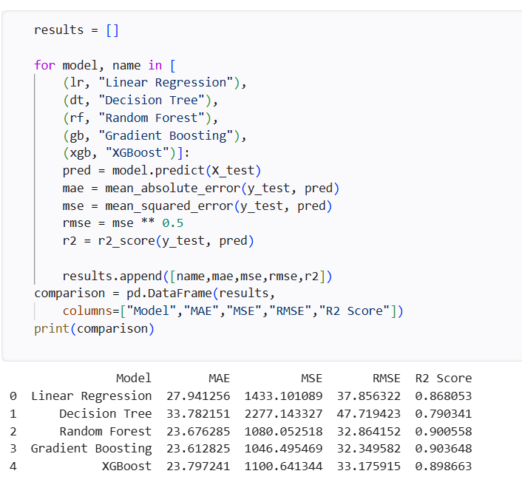
performance of all developed regression models was compared using four standard evaluation metrics: Mean Absolute Error (MAE), Mean Squared Error (MSE), Root Mean Squared Error (RMSE), and R² Score. Lower values of MAE, MSE, and RMSE indicate better prediction accuracy, while a higher R² Score indicates a better fit of the model to the data.
Model | MAE | MSE | RMSE | R² Score
Linear Regression | 27.94 | 1433.10 | 37.86 | 0.8681
Decision Tree | 33.78 | 2277.14 | 47.72 | 0.7903
Random Forest | 23.68 | 1080.05 | 32.86 | 0.9006
Gradient Boosting | 23.61 | 1046.50 | 32.35 | 0.9036
XGBoost | 23.80 | 1100.64 | 33.18 | 0.8987
The overall comparison of machine learning models highlights the following:
- Gradient Boosting Regressor achieved the lowest MAE (23.61), lowest MSE (1046.50), lowest RMSE (32.35), and the highest R² Score (0.9036).
- Random Forest Regressor produced the second-best performance with an R² Score of 0.9006 and low prediction errors.
- XGBoost Regressor also achieved excellent results with an R² Score of 0.8987, demonstrating strong predictive capability.
- Linear Regression performed well as a baseline model, achieving an R² Score of 0.8681, but produced higher prediction errors than the ensemble methods.
- Decision Tree Regressor recorded the highest MAE, MSE, and RMSE along with the lowest R² Score (0.7903), indicating comparatively lower prediction accuracy.

Model Ranking
Rank | Model | Performance
1 | Gradient Boosting | Best Performance
2 | Random Forest | Excellent Performance
3 | XGBoost | Very Good Performance
4 | Linear Regression | Good Baseline Model
5 | Decision Tree | Lowest Performance

• Gradient Boosting provides the most accurate house price predictions among all evaluated models.
• Random Forest and XGBoost also demonstrate excellent predictive performance with low prediction errors.
• Linear Regression serves as an effective baseline but is less capable of capturing complex nonlinear relationships.
• Decision Tree exhibits the lowest prediction accuracy due to its tendency to overfit the training data.
• Overall, ensemble learning algorithms outperform individual regression models in predicting house prices.
1.MAE (Mean Absolute Error)

Formula: MAE=1/n ∑ ∣y actual​−y predicted​∣
Lower is better.

2.. MSE (Mean Squared Error)

Formula: MSE=1/n ∑(y actual​−y predicted​)**2
Lower is better.

3.RMSE (Root Mean Squared Error)

Formula: RMSE= 1/2 MSE
​
4, ​R² Score (Coefficient of Determination)

Formula: R2=1−​SS residual​​/SS total

4.3.11 Hyperparameter Tuning using GridSearchCV
GridSearchCV was applied to the Gradient Boosting Regressor to identify the optimal parameter values that maximize prediction accuracy.
GridSearchCV systematically evaluates multiple combinations of hyperparameters using 5-fold cross-validation and selects the combination that produces the highest R² Score. This process helps improve model accuracy, reduce overfitting, and enhance the model's ability to generalize to unseen data.

Hyperparameters Considered
- n_estimators: Number of boosting stages (100, 200, 300)
- learning_rate: Learning rate controlling the contribution of each tree (0.05, 0.10)
- max_depth: Maximum depth of individual decision trees (3, 5, 7)
- min_samples_split: Minimum samples required to split an internal node (2, 5)
- min_samples_leaf: Minimum samples required at a leaf node (1, 2)
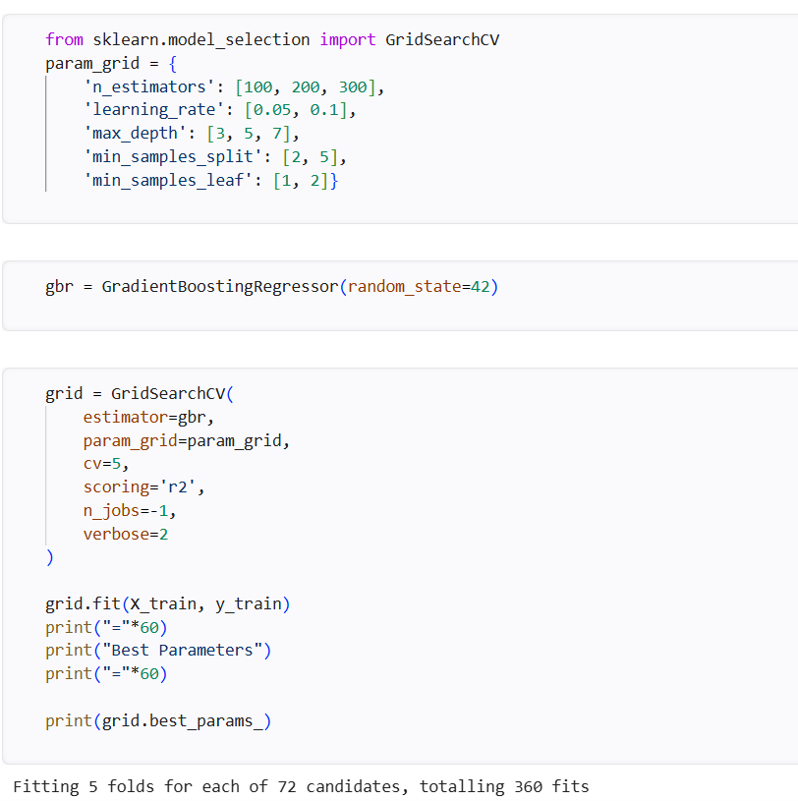

Interpretation
- GridSearchCV evaluated multiple combinations of hyperparameters using 5-fold cross-validation.
- The parameter combination with the highest R² Score was selected automatically.
- Hyperparameter tuning improves the model's prediction accuracy and robustness.
- The optimized Gradient Boosting model is expected to perform better than the default model.
- The selected hyperparameters provide a balance between model complexity and generalization.
Comparison of Machine Learning Models using Bar Chart
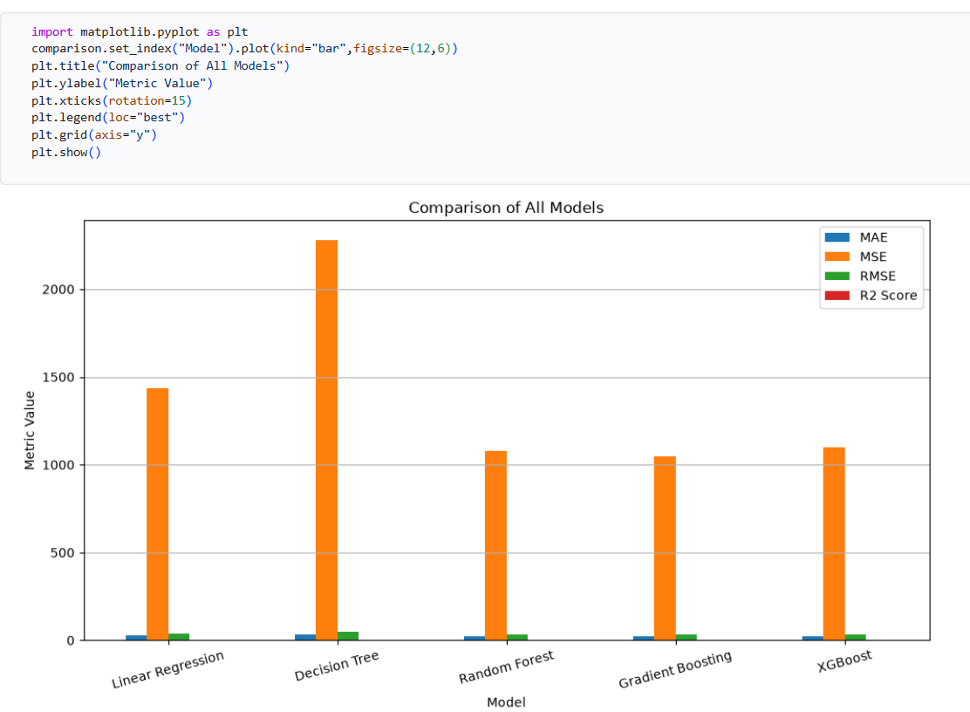

Interpretation
- The Gradient Boosting Regressor achieved the lowest MAE, MSE, and RMSE, indicating the highest prediction accuracy.
- Random Forest and XGBoost also demonstrated excellent performance with relatively low prediction errors.
- Linear Regression produced moderate prediction accuracy and served as a reliable baseline model.
- Decision Tree Regressor recorded the highest MAE, MSE, and RMSE, indicating the lowest prediction performance among the evaluated models.
- The R² Score is highest for Gradient Boosting (0.9036), followed by Random Forest (0.9006) and XGBoost (0.8987).
- The bar chart clearly demonstrates that ensemble learning algorithms outperform traditional regression models. Among all evaluated models, the Gradient Boosting Regressor achieved the best overall performance by producing the lowest prediction errors (MAE, MSE, and RMSE) and the highest R² Score (0.9036). T

After training all machine learning models, their performance was compared using the R² Score, which measures how well each model explains the variation in house prices. A higher R² Score indicates better prediction accuracy and model performance. Comparing multiple models helps identify the most suitable algorithm for house price prediction.
- Gradient Boosting Regressor achieved the highest R² Score (0.9036), indicating the best prediction accuracy.
- Random Forest Regressor achieved an R² Score of 0.9006, making it the second-best performing model.
- XGBoost Regressor obtained an R² Score of 0.8987, demonstrating excellent predictive performance.
- Linear Regression achieved an R² Score of 0.8681, providing a good baseline model.
- Decision Tree Regressor recorded the lowest R² Score (0.7903) among all the evaluated models.

Importing the SHAP Library
SHAP (SHapley Additive exPlanations) library was imported. SHAP is an Explainable Artificial Intelligence (XAI) technique that explains how each input feature contributes to the model's prediction.

SHAP Summary Plot (Explainable AI Analysis)
SHAP (SHapley Additive exPlanations) was applied. SHAP is an Explainable Artificial Intelligence (XAI) technique that explains how each feature contributes to the predicted house price.

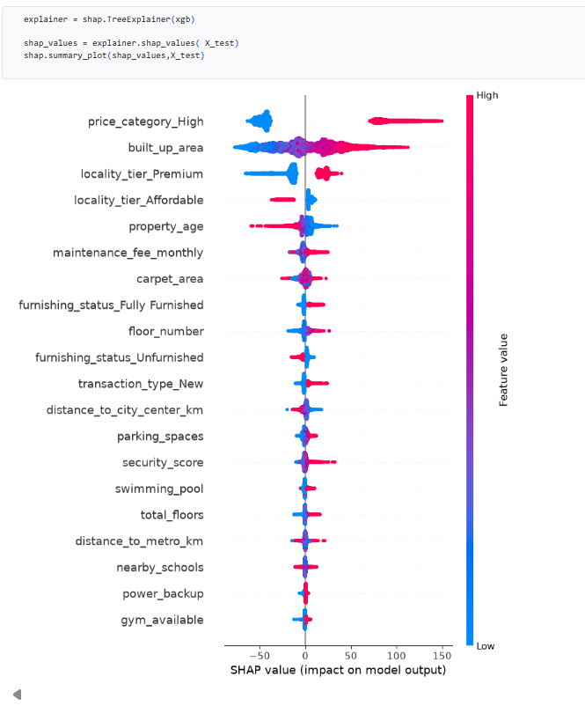
• Price Category (High) has the greatest influence on the predicted house price.
• Built-up Area is one of the most important features, with larger areas generally increasing house prices.
• Premium Locality Tier has a positive impact on property prices, while affordable localities contribute less.
• Property Age shows a negative influence, indicating that older properties tend to have lower prices.
• Maintenance Fee and Carpet Area also contribute significantly to the model's predictions.
• Features such as Furnishing Status, Floor Number, Distance to City Center, Parking Spaces, Security Score, Swimming Pool, Nearby Schools, and Power Backup have moderate influence on house price prediction.
• Gym Availability has the least impact among the displayed features.

Feature Importance Analysis:
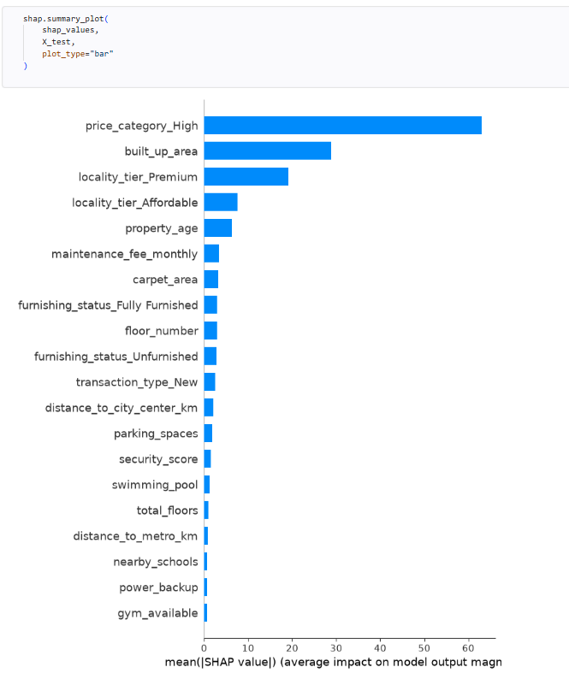
Interpretation:

Most Influential Factors:
most important features will be genuine predictors such as:
- Built-up Area
- Carpet Area
- BHK
- Bathrooms
- Locality Tier
- Property Age
- Maintenance Fee
- Distance to City Center
- Parking Spaces
- Security Score
These are real factors that influence house prices and make the model valid.

4.3.12 New House Price Prediction:

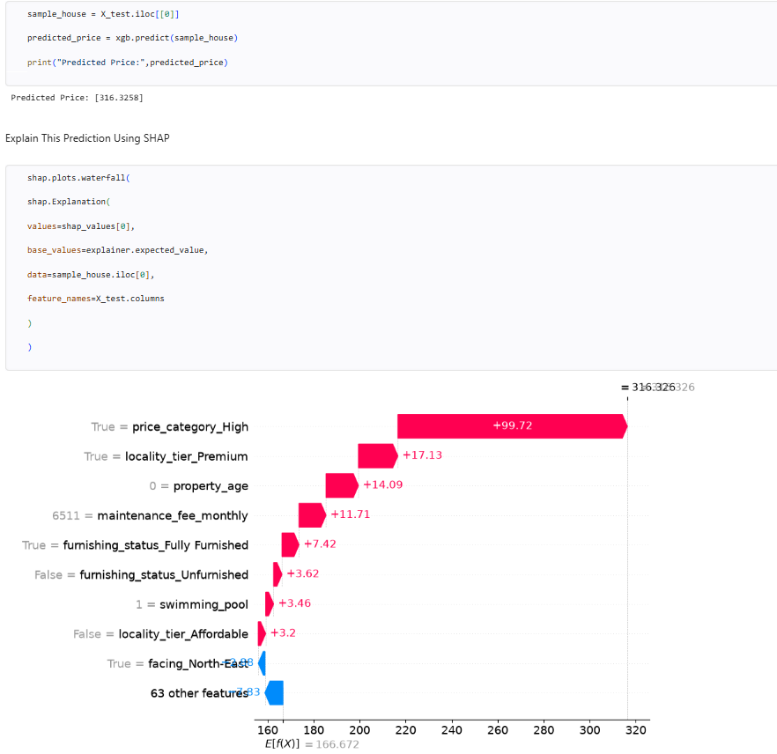
SHAP Waterfall Plot for an Individual House Prediction
• The model predicted a house price of approximately ₹316.33 lakhs.
• The base value of the model is approximately ₹166.67 lakhs, representing the average predicted house price.
• Premium locality significantly increases the predicted house price.
• Lower property age contributes positively to the prediction.
• Higher maintenance fee indicates a premium property and increases the predicted value.
• Fully furnished status positively influences the estimated house price.
• Some features reduce the prediction slightly, while others increase it, resulting in the final predicted value.
\

4.4 RESULTS AND DISCUSSION

4.4.1 Discussion of Model Performance
To evaluate the effectiveness of the proposed house price prediction system, five machine learning regression models were implemented and compared:
- Linear Regression
- Decision Tree Regressor
- Random Forest Regressor
- Gradient Boosting Regressor
- XGBoost Regressor
The performance of each model was evaluated using Mean Absolute Error (MAE), Mean Squared Error (MSE), Root Mean Squared Error (RMSE), and R² Score. These evaluation metrics provide a comprehensive assessment of prediction accuracy and model performance.

1. Linear Regression
The Linear Regression model achieved an R² Score of 0.8681, indicating good predictive performance for house price estimation. As a baseline regression model, it successfully captured the linear relationship between property features and house prices.
The model performed well because:
- It effectively models linear relationships between independent variables and house prices.
- It provides a simple and interpretable prediction model.
- It serves as a benchmark for comparing advanced machine learning algorithms.
However, the model has limitations in capturing complex nonlinear relationships present in the housing dataset.

2. Decision Tree Regressor
The Decision Tree Regressor achieved an R² Score of 0.7903, which is lower than the other models.
The model characteristics include:
- It captures nonlinear relationships between property features.
- It is easy to understand and visualize.
- It automatically performs feature selection during training.
- It is prone to overfitting when used as a single decision tree.
The relatively lower prediction accuracy indicates that a single decision tree is less effective for large and complex housing datasets.

3. Random Forest Regressor
The Random Forest Regressor achieved an R² Score of 0.9006, demonstrating excellent prediction performance.
The model performed well because:
- It combines multiple decision trees using ensemble learning.
- It reduces overfitting through bootstrap aggregation (bagging).
- It captures both linear and nonlinear relationships among property features.
- It provides stable and reliable predictions for unseen data.
The lower prediction errors and high R² Score indicate that Random Forest is highly suitable for house price prediction.

4. Gradient Boosting Regressor
The Gradient Boosting Regressor achieved the highest R² Score of 0.9036, making it the best-performing model in this study.
The model performed exceptionally well because:
- It builds trees sequentially by correcting the errors of previous trees.
- It minimizes prediction errors through iterative learning.
- It effectively captures complex nonlinear relationships among housing features.
- It provides high prediction accuracy with low MAE, MSE, and RMSE values.
Its superior performance demonstrates that boosting techniques are highly effective for predicting residential property prices.

5. XGBoost Regressor
The XGBoost Regressor achieved an R² Score of 0.8987, indicating excellent predictive performance.
The model performed well because:
- It implements an optimized gradient boosting algorithm.
- It efficiently handles large-scale datasets.
- It captures complex feature interactions.
- It includes regularization techniques that reduce overfitting.
Although its performance is slightly lower than Gradient Boosting, it remains one of the most accurate models for house price prediction.
factors.

5. CONCLUSION

5.1 CONCLUSION
This project successfully developed an AI-Based House Price Prediction and Real Estate Analytics System using statistical analysis, machine learning techniques, and Explainable Artificial Intelligence (XAI). The primary objective of the study was to accurately predict residential property prices based on various structural, geographical, and neighborhood characteristics. The proposed system utilized a housing dataset containing 50,000 residential property records with 30 features, representing major metropolitan cities in India.
The dataset was preprocessed and analyzed using various statistical and visualization techniques to understand the characteristics of residential properties and identify the factors influencing house prices. Multiple machine learning regression models were developed and evaluated to determine the most suitable algorithm for house price prediction. Furthermore, SHAP Explainable AI was incorporated to improve the transparency and interpretability of the developed prediction model.
The major findings of the study are summarized below:
- The housing dataset consisted of 50,000 residential property records with 30 property-related features.
- Data preprocessing successfully handled missing value analysis, duplicate record verification, categorical variable encoding, feature selection, and train-test data splitting.
- Exploratory Data Analysis (EDA) and descriptive statistics provided valuable insights into the distribution and characteristics of residential property prices.
- Statistical techniques such as Pearson Correlation Analysis, Multiple Linear Regression, One-Way ANOVA, Chi-Square Test, and Principal Component Analysis (PCA) confirmed the significant relationships between property characteristics and house prices.
- Features such as built-up area, carpet area, locality tier, BHK, bathrooms, maintenance fee, property age, parking spaces, and distance to the city center were identified as major factors influencing house prices.
- Five machine learning regression models (Linear Regression, Decision Tree Regressor, Random Forest Regressor, Gradient Boosting Regressor, and XGBoost Regressor) were successfully implemented and compared.
- Among all the evaluated models, the Gradient Boosting Regressor achieved the best prediction performance with an R² Score of 0.9036, followed by Random Forest (0.9006) and XGBoost (0.8987).
- The Gradient Boosting Regressor also produced the lowest MAE, MSE, and RMSE, making it the most suitable model for house price prediction.
- SHAP (SHapley Additive exPlanations) successfully explained the contribution of individual features to the predicted house prices, improving the transparency and interpretability of the machine learning model.
- The proposed system demonstrates that ensemble learning algorithms outperform traditional regression techniques for structured housing datasets.
- The developed prediction system provides accurate, reliable, and data-driven house price estimates that can support home buyers, sellers, investors, financial institutions, and real estate professionals in making informed decisions.
Overall, the project successfully achieved all the research objectives, including data preprocessing, exploratory data analysis, statistical analysis, machine learning model development, model evaluation, model comparison, hyperparameter tuning, and Explainable Artificial Intelligence (XAI). The proposed system provides a practical and efficient solution for residential property price prediction and demonstrates the effectiveness of integrating statistical techniques with advanced machine learning algorithms for real-world real estate analytics.
Top of Form

Bottom of Form

5.2 LIMITATIONS
Although the proposed AI-Based House Price Prediction and Real Estate Analytics System achieved good prediction accuracy, several limitations should be considered.

1. Dataset Coverage
The housing dataset contains 50,000 residential property records collected from selected metropolitan cities in India. Although the dataset is large, it does not represent all cities, towns, or rural regions. Therefore, the developed model may not fully capture the diversity of the Indian real estate market.

2. Limited Feature Scope
The prediction model considers only the available property-related features, such as:
- Built-up area
- Carpet area
- BHK
- Bathrooms
- Property age
- Parking spaces
- Locality tier
- Furnishing status
- Distance to the city center
- Maintenance fee
Other important factors that may influence house prices were not included, such as:
- Economic conditions
- Interest rates
- Government policies
- Market demand and supply
- Future infrastructure development

3. Static Dataset
The dataset represents property information collected at a specific point in time. House prices continuously change due to market trends and economic conditions. Therefore, the current model does not capture real-time fluctuations in the real estate market.

4. Model Dependency
The prediction accuracy depends on the quality and completeness of the training dataset. If the input data contains inaccurate, outdated, or incomplete information, the model's prediction performance may decrease.

5. Limited Generalization
The machine learning models were trained and evaluated using the same dataset through train-test splitting. Although the models demonstrated good performance, they were not validated using an independent external housing dataset. Therefore, the generalization capability of the model for unseen real-world datasets requires further validation.

6. Prediction Uncertainty
House prices are influenced by several unpredictable factors that cannot always be represented in structured datasets. Unexpected market changes, economic fluctuations, legal regulations, and local development projects may affect property prices, making exact prediction difficult.

7. Explainable AI Limitation
Although SHAP improves the interpretability of the prediction model by explaining feature contributions, it explains only the behavior of the trained machine learning model. SHAP does not establish a direct cause-and-effect relationship between property features and house prices.

These limitations indicate that while the proposed system provides accurate and reliable house price predictions, its performance depends on the quality of the available data and the selected features. Future improvements can enhance the system by incorporating larger datasets, real-time property listings, additional economic indicators, and external validation to improve prediction accuracy and generalization.
diagnosis.

5.3 FUTURE SCOPE
The proposed AI-Based House Price Prediction and Real Estate Analytics System provides a strong foundation for intelligent property price estimation. However, several enhancements can be incorporated to improve its accuracy, scalability, and real-world applicability.

1. Real-Time Data Integration
Future work can incorporate live property listings collected from real estate websites through APIs or web scraping. This will enable the prediction model to estimate house prices based on the latest market trends and property information.

2. Integration of Geospatial Information
Future enhancements may include location-based features such as:
- GPS coordinates
- GIS (Geographic Information System) data
- Nearby transportation facilities
- Commercial and educational zones
- Environmental and neighborhood quality
These features can improve location-specific house price prediction.

3. Advanced Machine Learning and Deep Learning
Although Gradient Boosting achieved the best performance, future research can evaluate more advanced techniques such as:
- Artificial Neural Networks (ANN)
- Deep Neural Networks (DNN)
- Transformer-based Regression Models
- Ensemble Hybrid Models
These approaches may improve prediction accuracy for more complex housing datasets.

4. Feature Expansion
Additional factors affecting house prices can be incorporated, such as:
- Interest rates
- Inflation and economic indicators
- Population growth
- Crime rate
- Air quality
- Future infrastructure projects
- Market demand and supply
Including these variables can improve the robustness of the prediction model.

5. Deployment as a Real-Time Application
The proposed system can be extended into:
- A web-based house price prediction application
- A mobile real estate analytics application
- A dashboard for real estate agencies and property investors
Such systems can provide:
- Instant house price estimation
- Property comparison
- Investment recommendations
- Market trend analysis

6. Cloud-Based Deployment and Explainable AI
Future work can deploy the system on cloud platforms and further enhance Explainable AI by:
- Integrating cloud-based prediction services
- Providing interactive SHAP visualizations
- Generating personalized prediction reports
- Improving transparency and user trust in AI-based property valuation

6. REFERENCES

- Keles, B., McCrae, N., & Grealish, A. (2020). The influence of social media on depression, anxiety and psychological distress in adolescents: A systematic review. Breiman, L. (2001). Random forests. Machine Learning, 45(1), 5–32.
- Friedman, J. H. (2001). Greedy function approximation: A gradient boosting machine. Annals of Statistics, 29(5), 1189–1232.
- Chen, T., & Guestrin, C. (2016). XGBoost: A scalable tree boosting system. Proceedings of the 22nd ACM SIGKDD International Conference on Knowledge Discovery and Data Mining, 785–794.
- Pedregosa, F., Varoquaux, G., Gramfort, A., et al. (2011). Scikit-learn: Machine learning in Python. Journal of Machine Learning Research, 12, 2825–2830.
- Lundberg, S. M., & Lee, S. I. (2017). A unified approach to interpreting model predictions. Advances in Neural Information Processing Systems (NeurIPS), 30, 4765–4774.
- James, G., Witten, D., Hastie, T., & Tibshirani, R. (2021). An Introduction to Statistical Learning (2nd ed.). Springer.
- Hastie, T., Tibshirani, R., & Friedman, J. (2021). The Elements of Statistical Learning (2nd ed.). Springer.
- Montgomery, D. C., Peck, E. A., & Vining, G. G. (2021). Introduction to Linear Regression Analysis (6th ed.). Wiley.
- Kutner, M. H., Nachtsheim, C., Neter, J., & Li, W. (2005). Applied Linear Statistical Models (5th ed.). McGraw-Hill.
- Bishop, C. M. (2006). Pattern Recognition and Machine Learning. Springer.
- Géron, A. (2022). Hands-On Machine Learning with Scikit-Learn, Keras & TensorFlow (3rd ed.). O'Reilly Media.
- Goodfellow, I., Bengio, Y., & Courville, A. (2016). Deep Learning. MIT Press.
- Vapnik, V. N. (1998). Statistical Learning Theory. Wiley.
- Han, J., Kamber, M., & Pei, J. (2012). Data Mining: Concepts and Techniques (3rd ed.). Morgan Kaufmann.
- Tan, P. N., Steinbach, M., & Kumar, V. (2019). Introduction to Data Mining (2nd ed.). Pearson.
- Hair, J. F., Black, W. C., Babin, B. J., & Anderson, R. E. (2019). Multivariate Data Analysis (8th ed.). Cengage Learning.
- Field, A. (2018). Discovering Statistics Using IBM SPSS Statistics (5th ed.). Sage Publications.
- Agresti, A. (2018). Statistical Methods for the Social Sciences (5th ed.). Pearson.
- Wooldridge, J. M. (2020). Introductory Econometrics: A Modern Approach (7th ed.). Cengage Learning.
- Belsley, D. A., Kuh, E., & Welsch, R. E. (2005). Regression Diagnostics: Identifying Influential Data and Sources of Collinearity. Wiley.
- National Association of Realtors. (2023). Real Estate Market Reports. National Association of Realtors.
- Zillow Research. (2023). Housing Market Data and Research. Zillow Inc.
- Housing.com Research Team. (2024). Indian Residential Real Estate Market Report. Housing.com.
- Magicbricks Research. (2024). India Real Estate Market Report. Magicbricks.
- Kaggle. (2024). Housing Price Prediction Dataset. Kaggle Inc.
- NumPy Developers. (2024). NumPy Documentation. NumPy Project.
- Pandas Development Team. (2024). Pandas User Guide. Pandas Documentation.
- Matplotlib Development Team. (2024). Matplotlib Documentation. Matplotlib Project.
- Seaborn Development Team. (2024). Seaborn Statistical Data Visualization Documentation. Seaborn Project.
- Python Software Foundation. (2024). Python Programming Language Documentation. Python Software Foundation.
31.Aurelien, G. (2022). Hands-On Machine Learning with Scikit-Learn, Keras, and TensorFlow (3rd ed.). O'Reilly Media.
32. Zillow Research. (2024). Zillow Home Value Index (ZHVI): Methodology and Housing Market Reports. Zillow Inc.

7. WEBSITES
- https://housing.com/
- https://scikit-learn.org/
- https://xgboost.readthedocs.io/
- https://shap.readthedocs.io/
- https://pandas.pydata.org/
- https://numpy.org/
- https://matplotlib.org/
- https://seaborn.pydata.org/
- https://www.magicbricks.com/
- https://www.99acres.com/
- https://www.analyticsvidhya.com/
- https://www.geeksforgeeks.org/
- https://towardsdatascience.com/
- https://www.python.org/

